慶豐 | 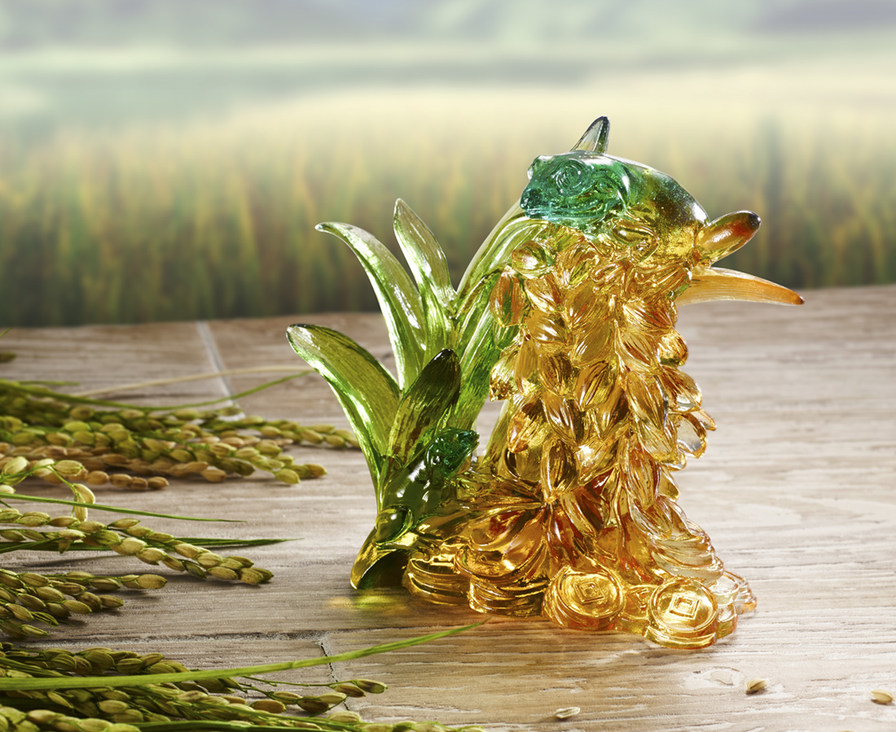
愈富足 愈謙虛
以最誠懇的心意
鳴謝年年歲歲的豐收
Frog and Spike
The frog and spike present an image of the countryside. While the spike turns to golden color, it conveys the joyfulness of harvest.

編號 | 1533688 | No | 1533688
名稱 | 慶豐 | Name | Frog and Spike
顏色 | 琥綠 | Color | amber ,green
尺寸 | 12.3 * 4.8 * 11.1 | Size | 12.3 * 4.8 * 11.1
重量 | 0.49 | Weight | 0.49
限量 | X | Limited Edition | X
售價 | NT$ 5680 | Price | NT$ 5680
 | RMB$ 1260 |  | RMB$ 1260

