春風如意 | 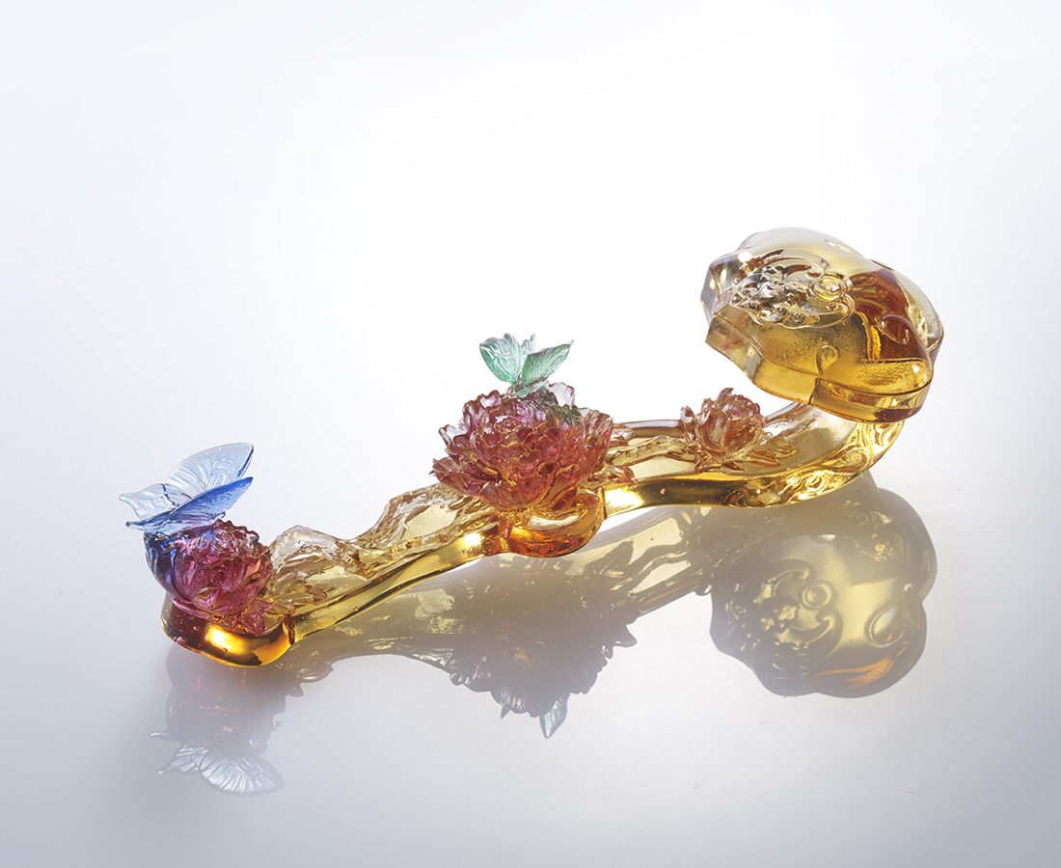
如意是
不斷蛻變的歷程
它高低起伏 優雅前進
它熱情擺舞 一路開花
Spring Prosperity
Pursuance of prosperity Is an ever-transforming process Through better or worse Striving forward elegantly With the passion of blooming flowers

編號 | 1532993 | No | 1532993
名稱 | 春風如意 | Name | Spring Prosperity
顏色 | 琥紅粉 | Color | null
尺寸 | 8 * 22.8 * 7.4 | Size | 8 * 22.8 * 7.4
重量 | 0.4 | Weight | 0.4
限量 | O | Limited Edition | O
售價 | NT$ 12850 | Price | NT$ 12850
 | RMB$ 2880 |  | RMB$ 2880

