生風 | 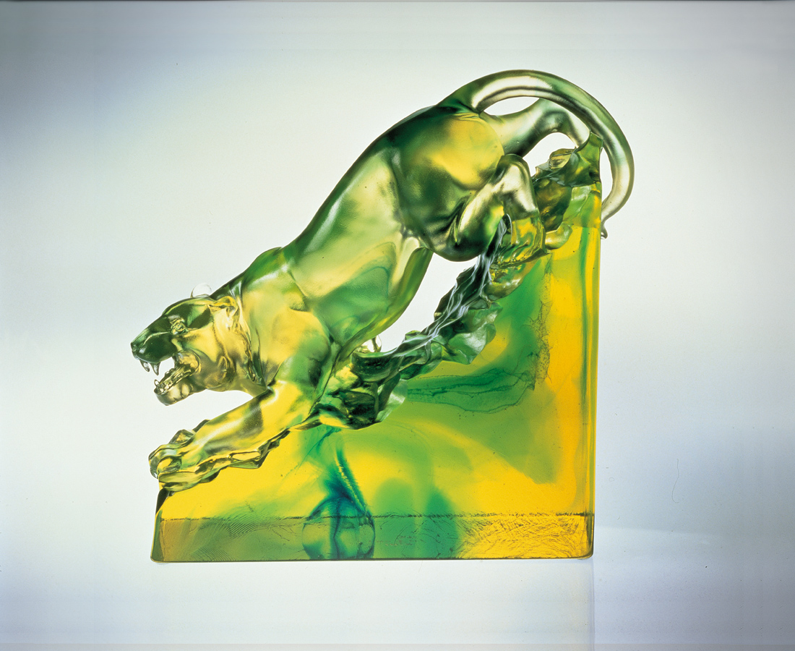
離開 林深雲霧的屏障
心中有多少準備和把握
下山 一步步篤定踏實
向雜亂的人世變化暴露
向未卜的事業風暴挺進
山下必然要
驚動而生風
Whirling
Leaving the screen of deep forest and mists Heart full of confidence and preparation Descending the mountain Each step firm, solid Exposed to the changes of a chaotic world Upright, moving towards unknown storms of profession The world will certainly be Startled and begin to whirl

編號 | 1526049 | No | 1526049
名稱 | 生風 | Name | Whirling
顏色 | 金綠 | Color
尺寸 | 22.2 * 9.3 * 19 | Size | 22.2 * 9.3 * 19
重量 | 6.0 | Weight | 6.0
限量 | O | Limited Edition | O
售價 | NT$ 51600 | Price | NT$ 51600
 | RMB$ 11688 |  | RMB$ 11688

