抱志 | 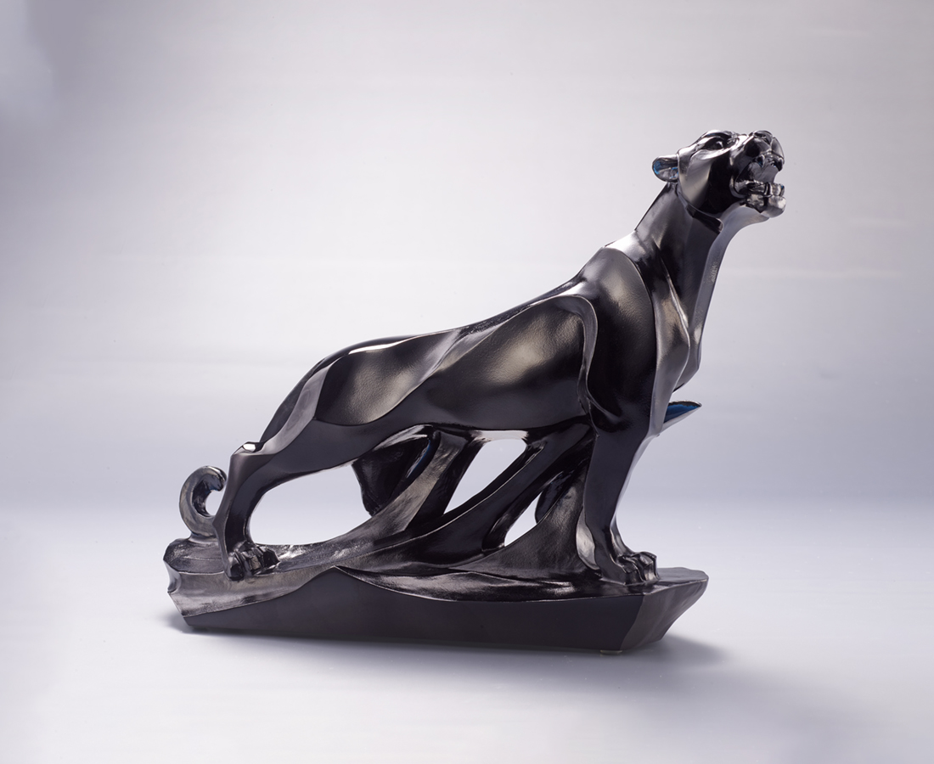
一呼嘯 眾生隨
雄才熒煌射秋水
破浪志 行篤敬
大略翹然奔絕塵
放眼世無比
四海誇英傑
Aspirations
The black panther often emanates a sense of mystery and agility, with its rhythmic muscular movement manifesting elegance. In Chinese culture, the panther is endowed with the image of bravery and fierceness. It is a natural hunter, always aiming at the target with unparalleled confidence, and achieving it at a lightning speed.

編號 | 1523993 | No | 1523993
名稱 | 抱志 | Name | Aspirations
顏色 | 深青 | Color | dark cyan
尺寸 | 27.5 * 8.5 * 19.5 | Size | 27.5 * 8.5 * 19.5
重量 | 2.8 | Weight | 2.8
限量 | O | Limited Edition | O
售價 | NT$ 24800 | Price | NT$ 24800
 | RMB$ 5900 |  | RMB$ 5900

