奮起乾坤 | 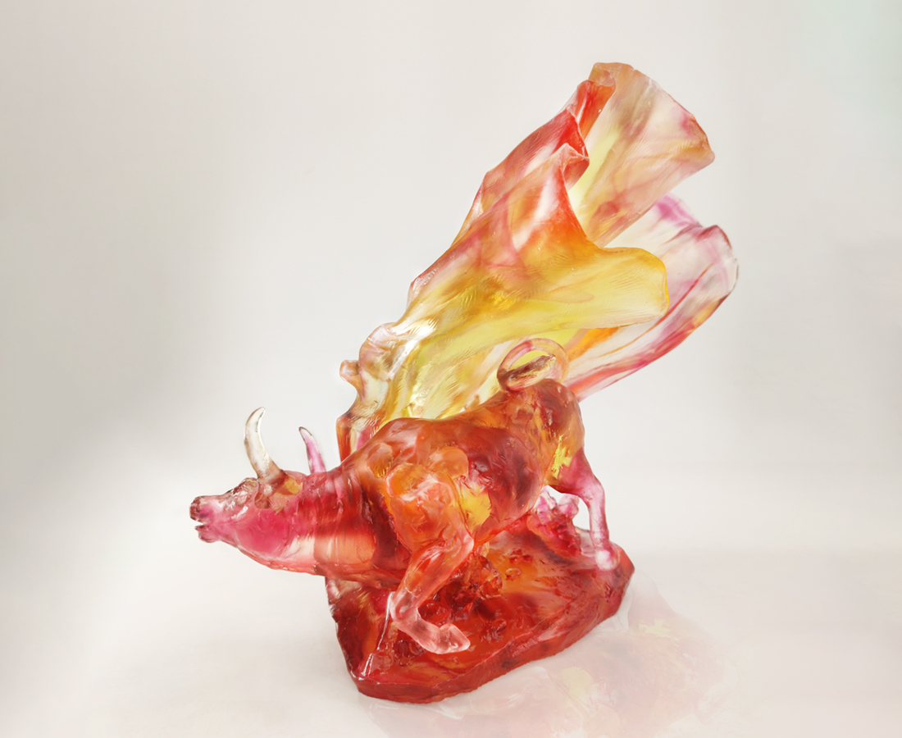
千山萬水始足下
步伐穩健 信念堅定
創新突破轉乾坤
無懼艱難 勇往直前
或見烏雲蔽日 或遇險阻困境
七轉八拐 尋得新機 探得宏運
終能
奮鬥的精神永存 成就一生的風采
Turning the Tables
The ox usually represents steadiness and courage. The artwork illustrates an ox agilely twisting its body and briskly running, showcasing the power and elegance, conveying the idea of marching forward courageously regardless of how harsh the situation is.

編號 | 1523931 | No | 1523931
名稱 | 奮起乾坤 | Name | Turning the Tables
顏色 | 金紅粉紅透 | Color | golden, red, pink, clear
尺寸 | 26 * 14.5 * 24.5 | Size | 26 * 14.5 * 24.5
重量 | 3.5 | Weight | 3.5
限量 | O | Limited Edition | O
售價 | NT$ 27800 | Price | NT$ 27800
 | RMB$ 6180 |  | RMB$ 6180

