扭轉亨通 | 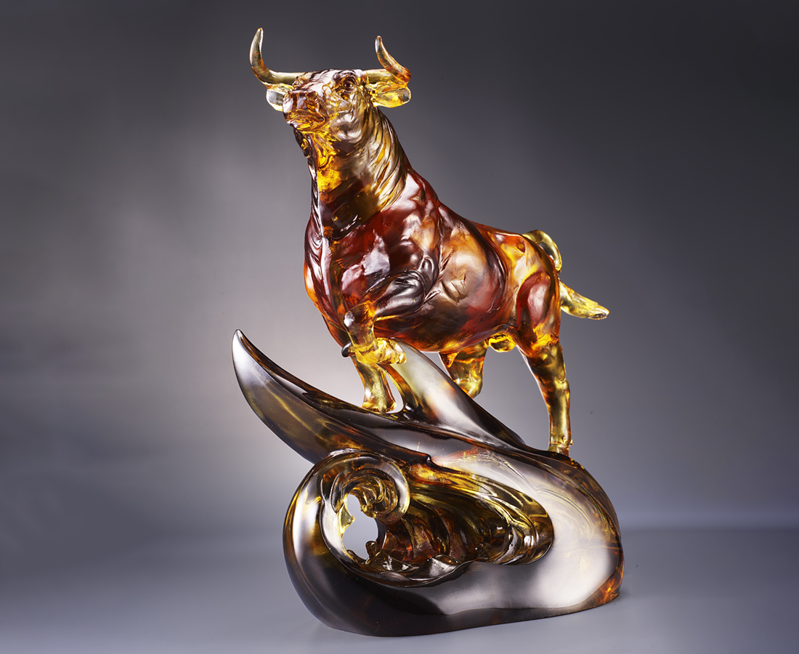
聲勢磅礡 浩蕩而來
眼裡只有目標 不曾懈怠
壯闊眼界 放手去闖
讓世界聽見自豪的奔跑聲
登上榮耀的殿堂
披著富貴的榮光
一路亨通 扭轉乾坤
Path to Success
The ox generally conveys steadiness and courage. The artwork shows the ox standing on top of winds and clouds while adamantly looking forward, symbolizing a bright and successful future in near sight.

編號 | 1523929 | No | 1523929
名稱 | 扭轉亨通 | Name | Path to Success
顏色 | 金琥茶灰透 | Color | Golden, amber, brown, gray, clear
尺寸 | 31 * 18 * 36 | Size | 31 * 18 * 36
重量 | 11.0 | Weight | 11.0
限量 | O | Limited Edition | O
售價 | NT$ 128600 | Price | NT$ 128600
 | RMB$ 28600 |  | RMB$ 28600

