勇往直前 | 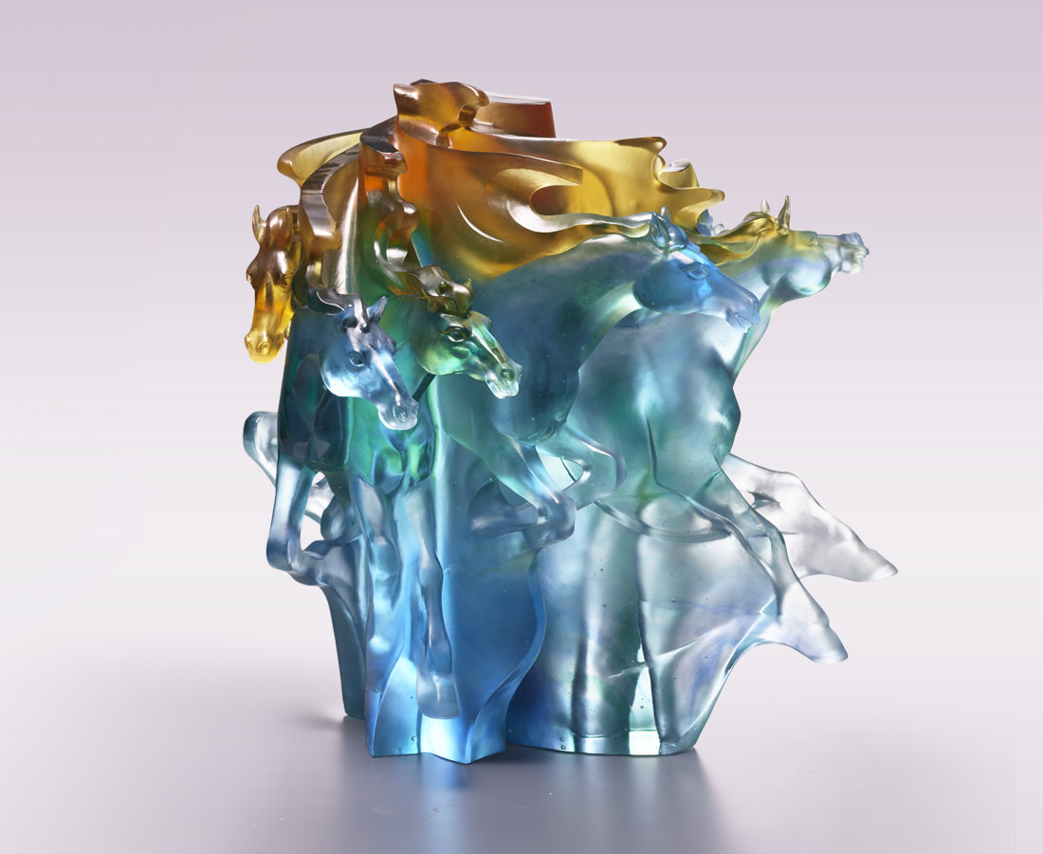
心有嚮往 意有所指
各各勇往直前
你爭先 我奮勇
齊心協力 前後呼應
前進 則功成名就
佇立 則怡然淡定
Going Forward Courageously
The artwork, with a circular axis, has a herd of horse running apart, showing an image of imposing manner, like thousands of horses stampeding through the wilderness. The repeating image of horses also illustrates the shadow of a horse running, conveying the confident manner of locking down a goal and keep going for it.

編號 | 1523886 | No | 1523886
名稱 | 勇往直前 | Name | Going Forward Courageously
顏色 | 藍青金透 / 茶灰透 | Color | blue, cyan, golden, clear / brown, gray,
尺寸 | 31.6 * 29 * 32 | Size | 31.6 * 29 * 32
重量 | 20.0 | Weight | 20.0
限量 | O | Limited Edition | O
售價 | NT$ 93800 | Price | NT$ 93800
 | RMB$ 20850 |  | RMB$ 20850

