嶄露鋒芒 | 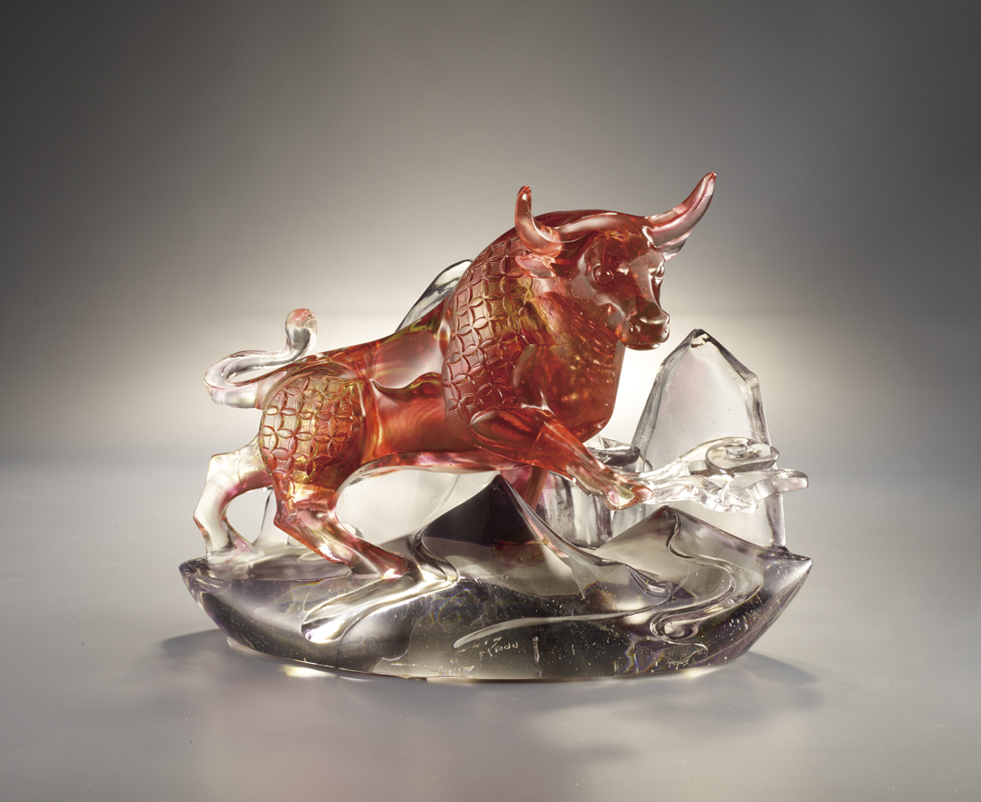
敦厚樸實 沉澱累積
在混沌之中
發現天驚地動的契機
突破重重障礙
踏出全新眼界
鋒芒
留給最耀眼的鍥而不捨
Bullfight
The breaking out bull symbolizes a Chinese wisdom, calmness comes before hastiness. Wait for the opportunity, when it appears, go for it courageously like a bull. The blocky look of the bull and its stand shows the strength of bull and the balance of color and shade.

編號 | 1523856 | No | 1523856
名稱 | 嶄露鋒芒 | Name | Bullfight
顏色 | 金紅灰透 / 紅金草綠青紫羅蘭透 | Color | golden, red, gray, clear / red, golden,
尺寸 | 29 * 17 * 23 | Size | 29 * 17 * 23
重量 | 8.5 | Weight | 8.5
限量 | O | Limited Edition | O
售價 | NT$ 54800 | Price | NT$ 54800
 | RMB$ 12200 |  | RMB$ 12200

