馳騁風雲 | 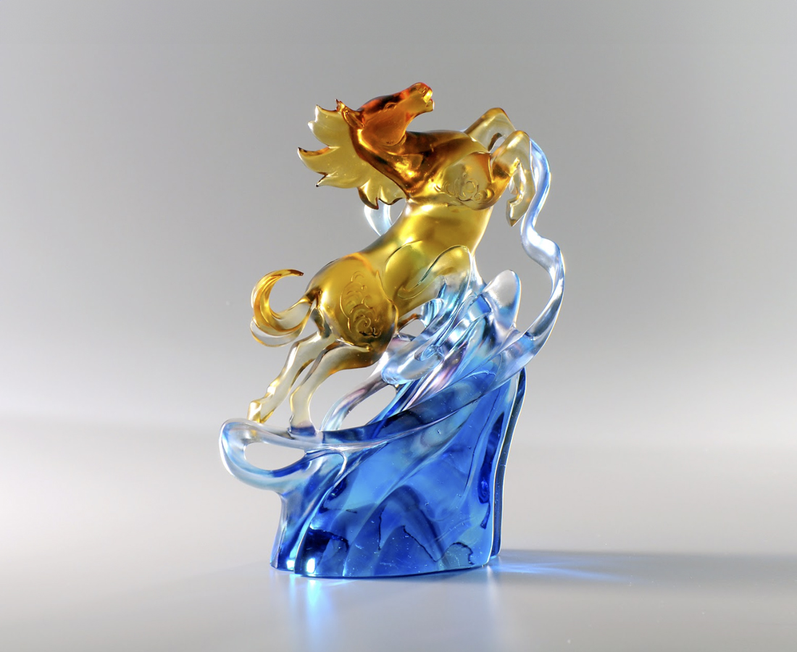
翻山越嶺
只為了更遼闊的大地
騰踏光明
只為了更璀璨的星空
凌越高峰之時
那銳不可擋的氣勢
馳騁極致
引領風雲
The Leaping Horse
In Oriental Culture, horse symbolizes the sky since it sprints forward freely. Tittot uses the sprinting horse to illustrate the spirit of courage and bravery in Chinese Culture. The polished stand demonstrates not only Tittot’s high standard on color and shades, but also the principle that only the ones who stands out can lead the future.

編號 | 1523853 | No | 1523853
名稱 | 馳騁風雲 | Name | The Leaping Horse
顏色 | 琥茶藍紫青透 | Color | amber, brown. blue, purple, cyan, clear
尺寸 | 21.4 * 11 * 31.4 | Size | 21.4 * 11 * 31.4
重量 | 5.7 | Weight | 5.7
限量 | O | Limited Edition | O
售價 | NT$ 52700 | Price | NT$ 52700
 | RMB$ 11720 |  | RMB$ 11720

