共存共榮 | 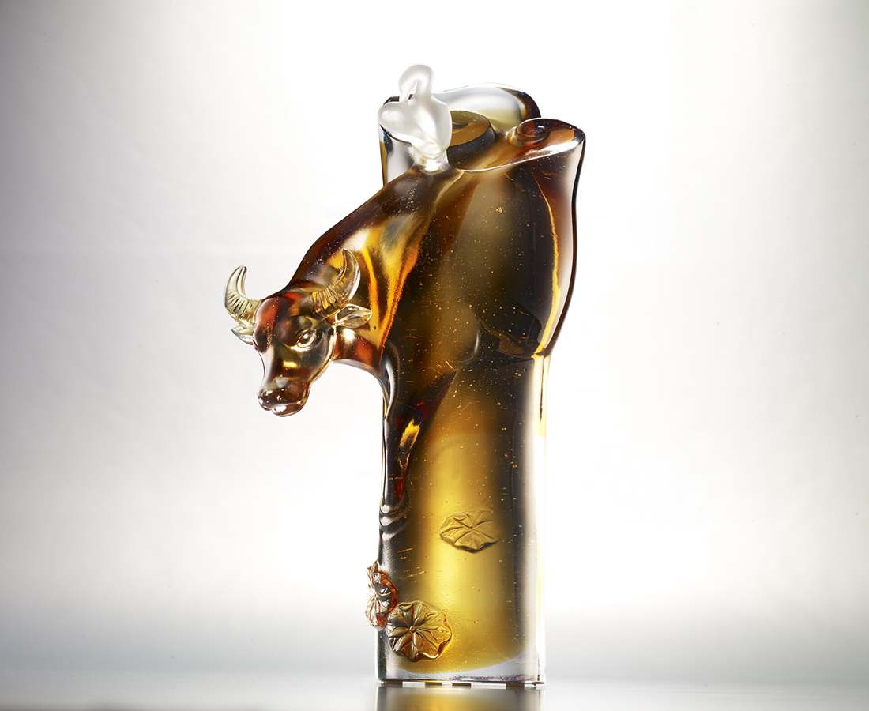
你呼我應 你高我低
互助 和諧
蓄起一飛衝天之勢
迎來雙贏的人龢年豐
Buffalo and Egrets
Egrets help the buffalo to clean its body, and the buffalo in return protects the egrets from attack by other birds. In Chinese culture, this illustrates the pursuit of a symbiotic relationship between man and nature, resulting in harmony and common prosperity.

編號 | 1523809 | No | 1523809
名稱 | 共存共榮 | Name | Buffalo and Egrets
顏色 | 茶琥粉透 | Color | brown, amber, pink, clear
尺寸 | 12.9 * 8.7 * 22.8 | Size | 12.9 * 8.7 * 22.8
重量 | 2.45 | Weight | 2.45
限量 | O | Limited Edition | O
售價 | NT$ 14800 | Price | NT$ 14800
 | RMB$ 3310 |  | RMB$ 3310

