如願以償 | 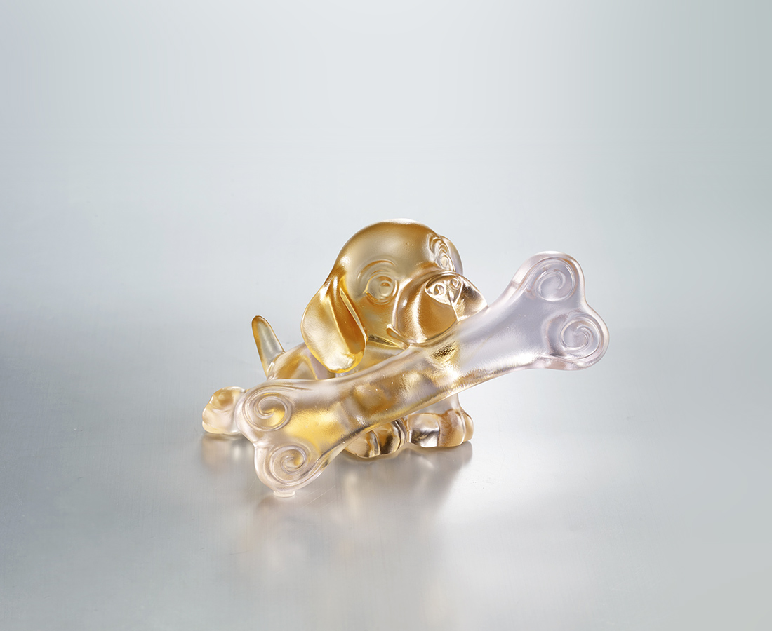
小小的夢想
築夢踏實 把握機會
就是大大的幸福
Wishes Fulfilled
A happy beagle contentedly biting on a big bone symbolizes the idea that with a down-to-earth attitude and effort even the tiniest dream can grow into the greatest happiness and success.

編號 | 1523783 | No | 1523783
名稱 | 如願以償 | Name | Wishes Fulfilled
顏色 | 粉琥 | Color | pink, amber
尺寸 | 11.9 * 11 * 7.5 | Size | 11.9 * 11 * 7.5
重量 | 0.49 | Weight | 0.49
限量 | X | Limited Edition | X
售價 | NT$ 4990 | Price | NT$ 4990
 | RMB$ 1120 |  | RMB$ 1120

