好金彩 | 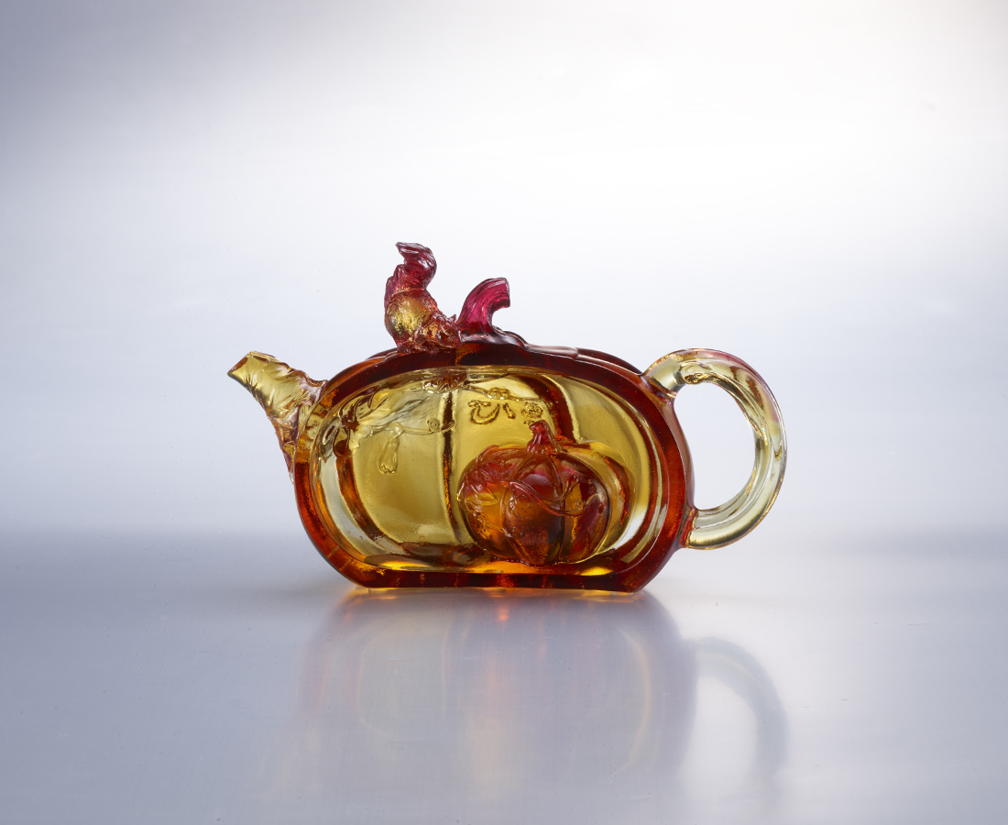
心也可以清
處處是驚喜
精彩迭連
無限榮景
Pumpkin Teapot
In Chinese culture, tea drinking is an art of living with long history. In the Ming Dynasty and Qing Dynasty, craftsmen made teapots into various meaningful and interesting forms so that tea drinking is not only enjoying the taste of tea, but also enjoying the art of visual and tactile. Pumpkin is a sweet fruit, and symbolizes a good memory when taking a drink.

編號 | 1523584 | No | 1523584
名稱 | 好金彩 | Name | Pumpkin Teapot
顏色 | 紅琥透 + 扇形底座 | Color | red , amber , clear ＋ stand
尺寸 | 15.4 * 6 * 9.5 | Size | 15.4 * 6 * 9.5
重量 | 0.6 | Weight | 0.6
限量 | X | Limited Edition | X
售價 | NT$ 6280 | Price | NT$ 6280
 | RMB$ 1400 |  | RMB$ 1400

