馬上光彩(小) | 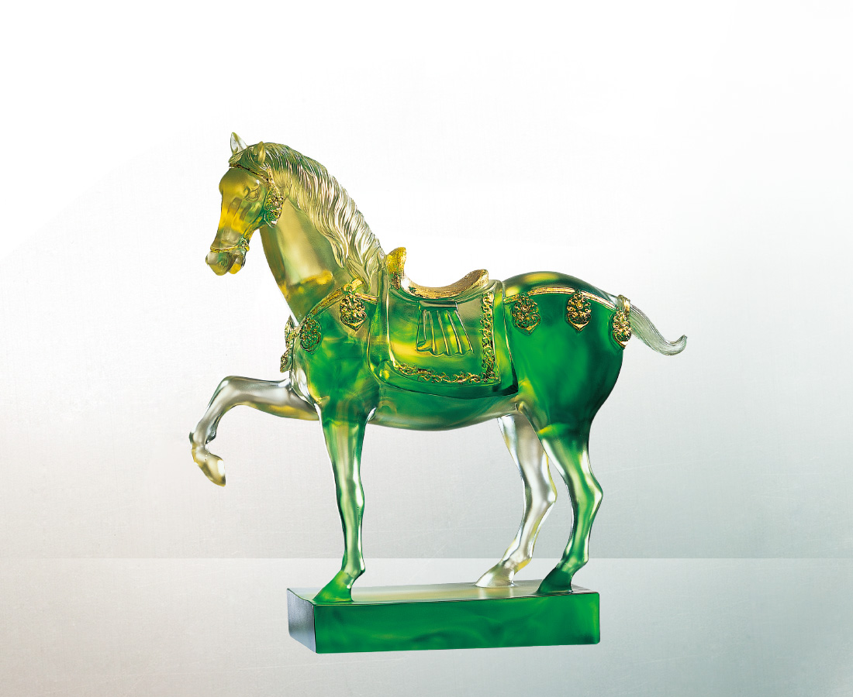
經驗多少歲歲月月
依然記憶鼎立盛氣
曾經無數動動盪盪
無法忘情碩美壯闊
歷史滄桑 莊重依然
文化境遷 歷久彌新
時代滾動 人文情懷
總又不禁輕抬起腳
勾住先人先覺美感
和永世的晶瑩剔透
Luster, Glory and Honor(little)
After experiencing vast expanses of time, Your memory is still as sharp and fresh as before; After enduring countless upheavals, You cannot be indifferent to beauty and grandeur; The vicissitudes of history…abiding solemnity; Cultural transformations…as new as ever; Turbulent times…humane leanings; It’s always hard to stop yourself from taking action To connect with the aesthetics that came before And the dazzling brilliance of eternity.

編號 | 1523451 | No | 1523451
名稱 | 馬上光彩(小) | Name | Luster, Glory and Honor(little)
顏色 | 金綠透+金箔 | Color | golden, green, clear + gilding
尺寸 | 15.2 * 4.7 * 15.5 | Size | 15.2 * 4.7 * 15.5
重量 | 0.64 | Weight | 0.64
限量 | X | Limited Edition | X
售價 | NT$ 9240 | Price | NT$ 9240
 | RMB$ 1960 |  | RMB$ 1960

