燦爛勝出 | 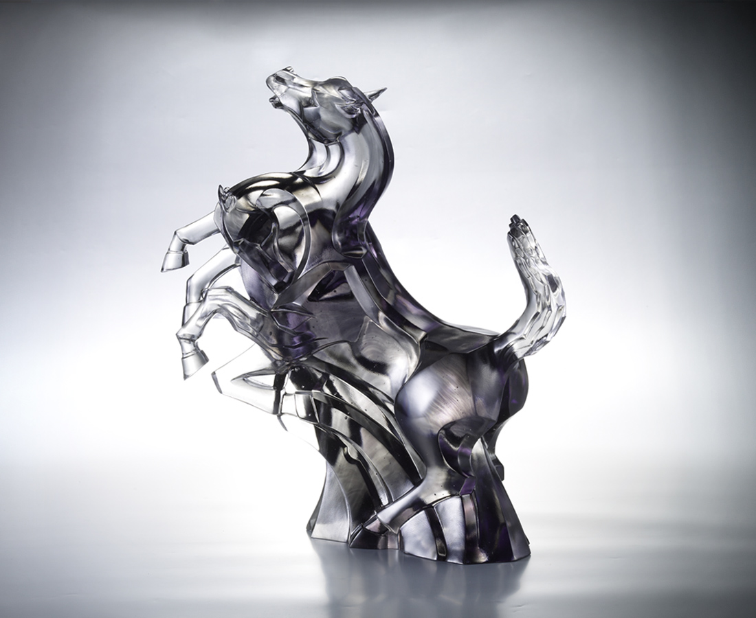
胸懷凌雲壯志
昂首爆發奔騰
信心凜然 張起萬丈凌人陣勢
活力澎湃 衝出波瀾壯闊極境
向高潮迭起盡放光芒
Ablaze Victory
Strong will across the sky Bursting in gallops with firmness With faith, we can be thousands of times braver With ardor, we can achieve what none have achieved We can roar in the light of all victories

編號 | 1523216 | No | 1523216
名稱 | 燦爛勝出 | Name | Ablaze Victory
顏色 | 灰透 | Color
尺寸 | 16.7 * 39.1 * 41 | Size | 16.7 * 39.1 * 41
重量 | 12.56 | Weight | 12.56
限量 | O | Limited Edition | O
售價 | NT$ 96800 | Price | NT$ 96800
 | RMB$ 21600 |  | RMB$ 21600

