好峰好水 | 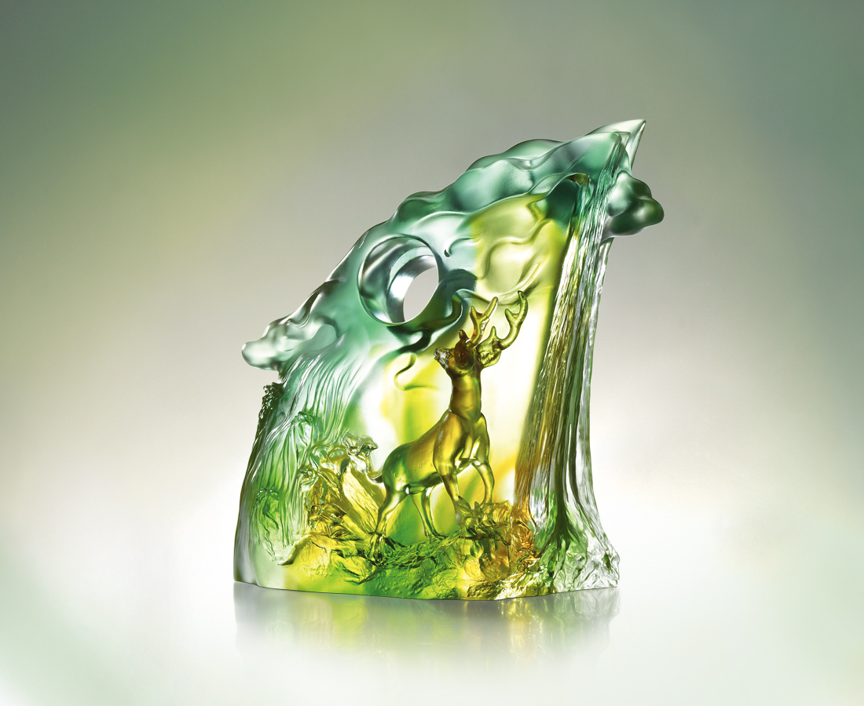
滾滾雲海 浩浩日出
衝破滿腔翻湧的熱望
創造光明燦爛的新境
照得高山 堅毅不拔
映得澗水 信心奔放
梅蘭交響 春禧福祿
繁榮景盛的標記
高高升起
Picture squeness
The boiling sea of clouds and the spectacular sunrise Fueled ambitions Leads to an ever brilliant future The arduous spirit that makes mountains shine The utter confidence that makes rivers glisten The orchestra of plum flower and orchids, the good fortune and wealth promised by spring Emblem of prosperity Raised high

編號 | 1522633 | No | 1522633
名稱 | 好峰好水 | Name | Picture squeness
顏色 | 青琥綠透 | Color | null
尺寸 | 11.8 * 21.8 * 23.3 | Size | 11.8 * 21.8 * 23.3
重量 | 5.5 | Weight | 5.5
限量 | O | Limited Edition | O
售價 | NT$ 28950 | Price | NT$ 28950
 | RMB$ 6730 |  | RMB$ 6730

