馬上封侯 | 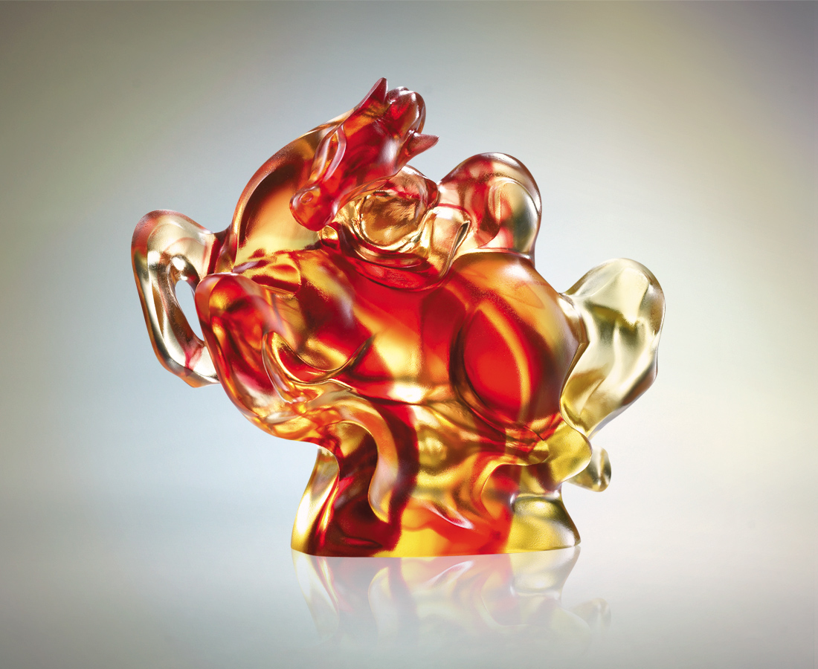
擺出圓融風姿
身段放低 信心貫注
追風起的節奏
隨雲湧的律動
蓄勢加碼 乘勢衝鋒
氣運和暢 馬上封侯
Taking the Throne
Put on the satisfactory position and Lower the figure to concentrate perfectly on The rhythm of the wind. With the swing of clouds Comes the increasing speed as well as taking the lead Which brings flowing fortune and throne on the horse.

編號 | 1522628 | No | 1522628
名稱 | 馬上封侯 | Name | Taking the Throne
顏色 | 金紅／藍青 | Color
尺寸 | 8 * 16.8 * 15.5 | Size | 8 * 16.8 * 15.5
重量 | 2.02 | Weight | 2.02
限量 | O | Limited Edition | O
售價 | NT$ 13800 | Price | NT$ 13800
 | RMB$ 3466 |  | RMB$ 3466

