神采輝耀 | 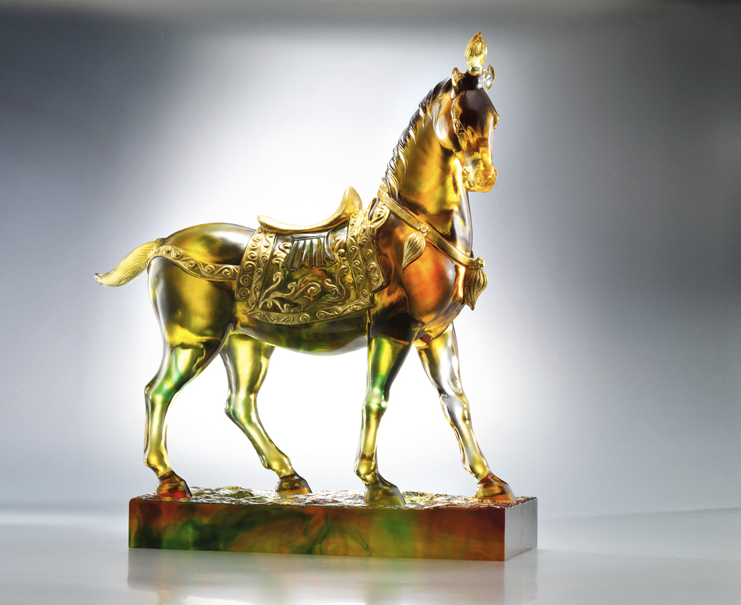
盎然飛動的身心
千年不改真摯
步步堅實
天地自然的氣韻
歷代不減熱情
風華絕倫
踏出 歷久彌新
雍容華麗的風範
Gallant And Brilliant
Born to run, jolly and sincere Nothing’s been changed a thousand years Surefooted, it is Dressed in the pride of Nature’s best Zestful through generations with nothing less Spectacular and elegant, it is Cantering in majestic and graceful pace Time makes no difference to its noble race

編號 | 1522539 | No | 1522539
名稱 | 神采輝耀 | Name | Gallant And Brilliant
顏色 | 琥綠透 | Color
尺寸 | 12.4 * 36.6 * 40.3 | Size | 12.4 * 36.6 * 40.3
重量 | 13.0 | Weight | 13.0
限量 | O | Limited Edition | O
售價 | NT$ 184800 | Price | NT$ 184800
 | RMB$ 42000 |  | RMB$ 42000

