愛得響亮 | 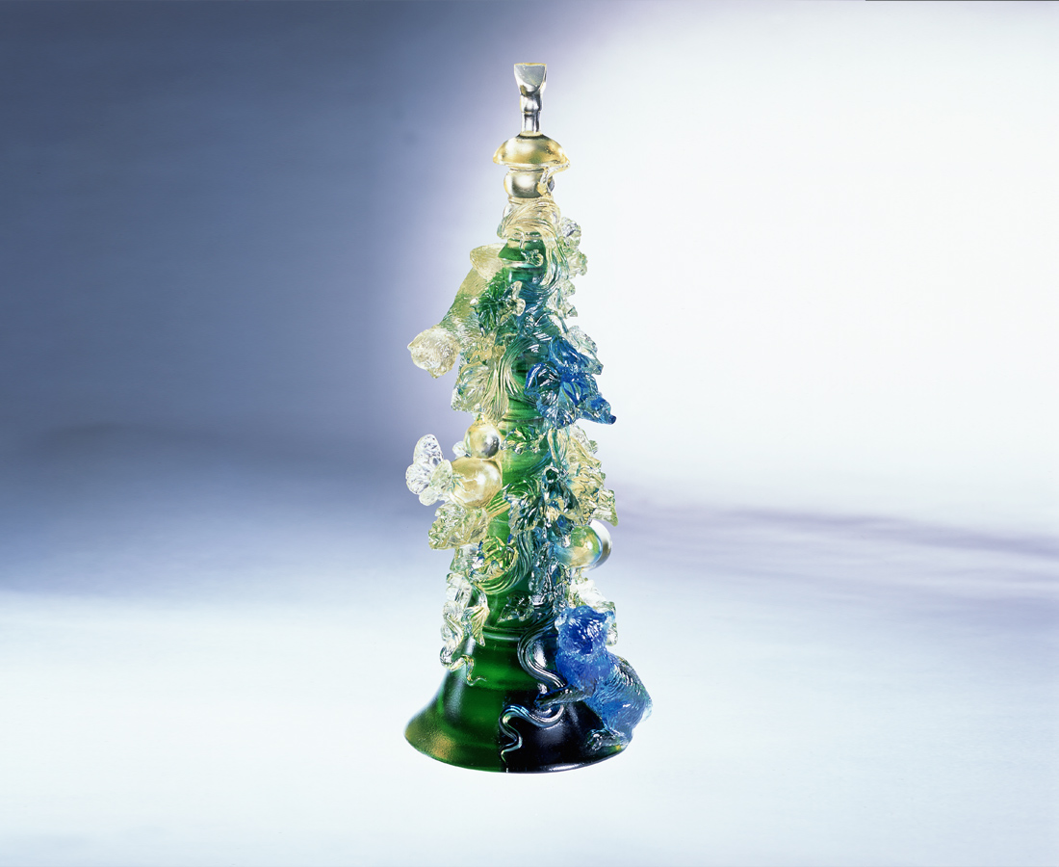
吹起高亢嘹亮的音
響亮活潑快樂的心
處處芳香 不停追尋
道道正途 不停前進
即使高低起伏千迴百轉
彼此勉勵 相互關懷
樂觀積極 福祿綿延
歡樂納福 滿庭富足
Love Is Loud
The high and loud music is blown Brighten hearts with its vigor and joy Constantly search amid the prevailing fragrance March on through the roads, all of which being the right track Despite the uneven and winding roads Encourage and care for each other Remaining optimistic and positive for lasting bliss and joy Receiving the bliss and full prosperity with delight

編號 | 1522126 | No | 1522126
名稱 | 愛得響亮 | Name | Love Is Loud
顏色 | 藍綠金 | Color
尺寸 | 4.6 * 6.7 * 17.8 | Size | 4.6 * 6.7 * 17.8
重量 | 0.66 | Weight | 0.66
限量 | X | Limited Edition | X
售價 | NT$ 6260 | Price | NT$ 6260
 | RMB$ 1566 |  | RMB$ 1566

