飲水思源 | 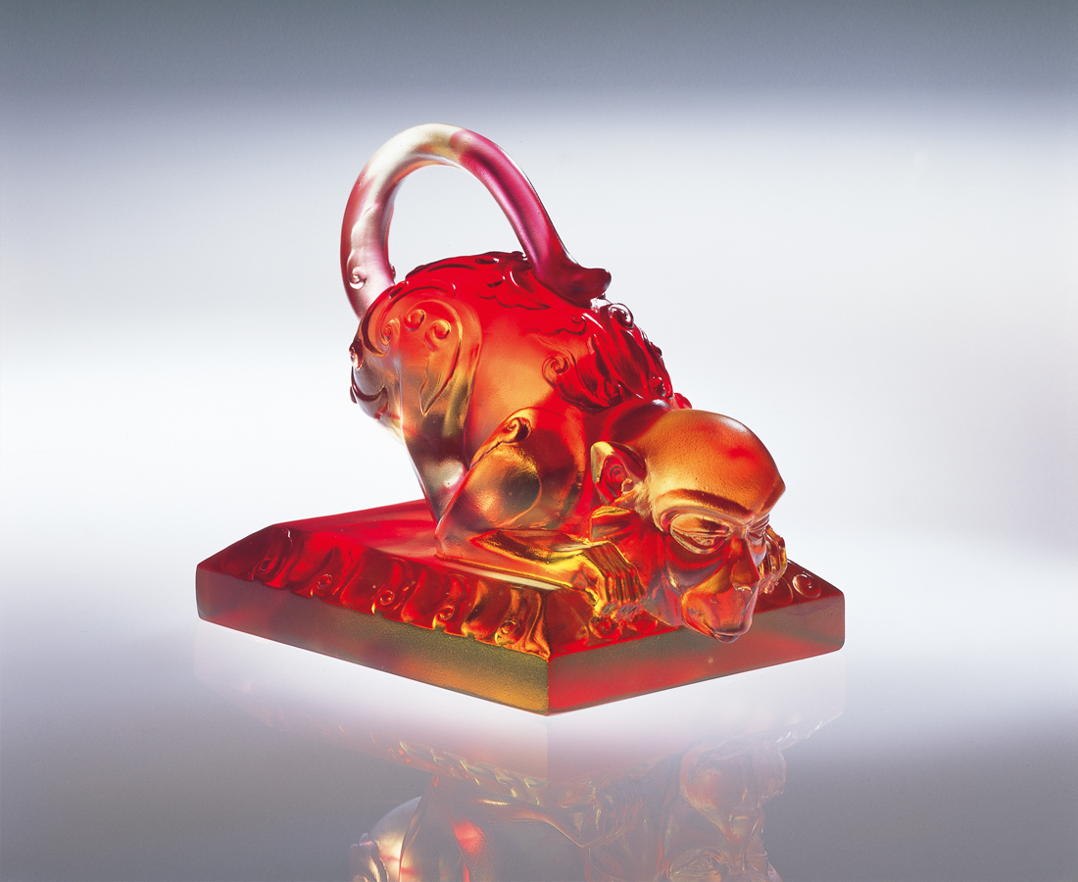
生生不息的心思鐘擺
勁道持續 謙卑誠懇
一邊是未來璀璨的願景
一邊是從前靈動的根源
承先啟動的開創不能停
心領神會的啟動要感恩
於是俯首虔誠深飲每一口
都是當初因緣際會的殊勝
都是明日神聖莊嚴的期許
Grateful for Favors
The everlasting pendulum in spirit Keep up the power with modesty and sincerity A bright vision in the future A clever origin in the past All profound creations will not stop Getting inspiration with a thankful heart Deeply and devoutly drinking in The remarkable and outstanding chances The sacred and dignified expectation

編號 | 1522026 | No | 1522026
名稱 | 飲水思源 | Name | Grateful for Favors
顏色 | 金紅透 | Color
尺寸 | 7 * 10.3 * 9 | Size | 7 * 10.3 * 9
重量 | 0.68 | Weight | 0.68
限量 | X | Limited Edition | X
售價 | NT$ 5280 | Price | NT$ 5280
 | RMB$ 1322 |  | RMB$ 1322

