真情真義 | 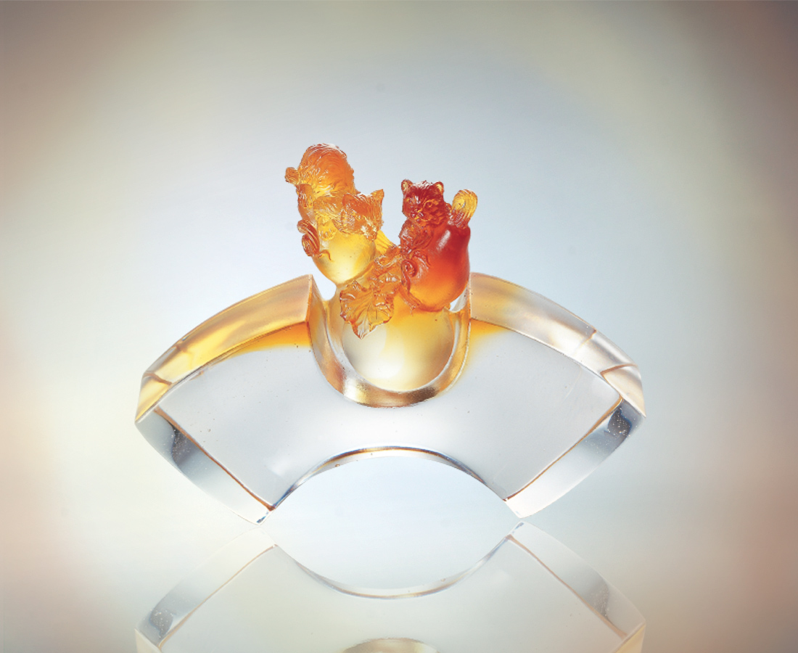
琥珀
扇開得天獨厚的福份
在穩健沉著裡是情義
在神聖尊貴中是誠信
我們是相敬如賓的知己
彼此珍惜似水隆情厚誼
共享自我與相互的觀照
而知真情真義的顏色
散發光明磊落的剔透光彩
True Affections
The amber stands for unique happiness, With affections contained in composedness; Honesty and trust are revealed in sacredness and dignity, As we are intimate friends respecting each other; Valuing the profound friendship between us, We share mutual tender loving care; The color standing for true affections, Emits the transparent light of being above-board.

編號 | 1520226 | No | 1520226
名稱 | 真情真義 | Name | True Affections
顏色 | 琥透 | Color
尺寸 | 5.3 * 15.8 * 11.8 | Size | 5.3 * 15.8 * 11.8
重量 | 1.3 | Weight | 1.3
限量 | X | Limited Edition | X
售價 | NT$ 9860 | Price | NT$ 9860
 | RMB$ 2288 |  | RMB$ 2288

