互助合作 | 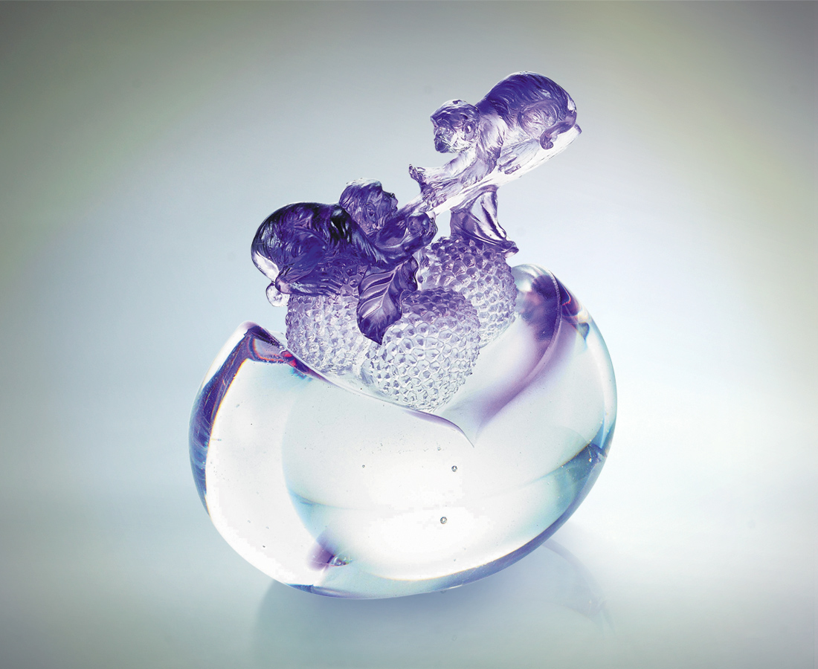
紫
深藏曼妙神奇的默契
在優雅端莊裡是激賞
在高貴祥和中是分享
我們有共榮共生的福報
彼此真心誠意地相授受
徜徉互信的歡愉篤定
而知合作無間的顏色
散發大開利市的剔透光彩
Mutual Cooperation
Purple has a miraculous magic in tacit agreement, as it signifies elegance and exciting admiration As well as nobility and share between us; We expect happiness in living with each other, loving each other with great sincerity and enjoying joy of mutual trust together; The brilliance of profit-making is emitted profusely in our close cooperation.

編號 | 1520215 | No | 1520215
名稱 | 互助合作 | Name | Mutual Cooperation
顏色 | 紫透 | Color
尺寸 | 6.7 * 10.1 * 11.5 | Size | 6.7 * 10.1 * 11.5
重量 | 0.9 | Weight | 0.9
限量 | X | Limited Edition | X
售價 | NT$ 9260 | Price | NT$ 9260
 | RMB$ 2288 |  | RMB$ 2288

