三生有幸 | 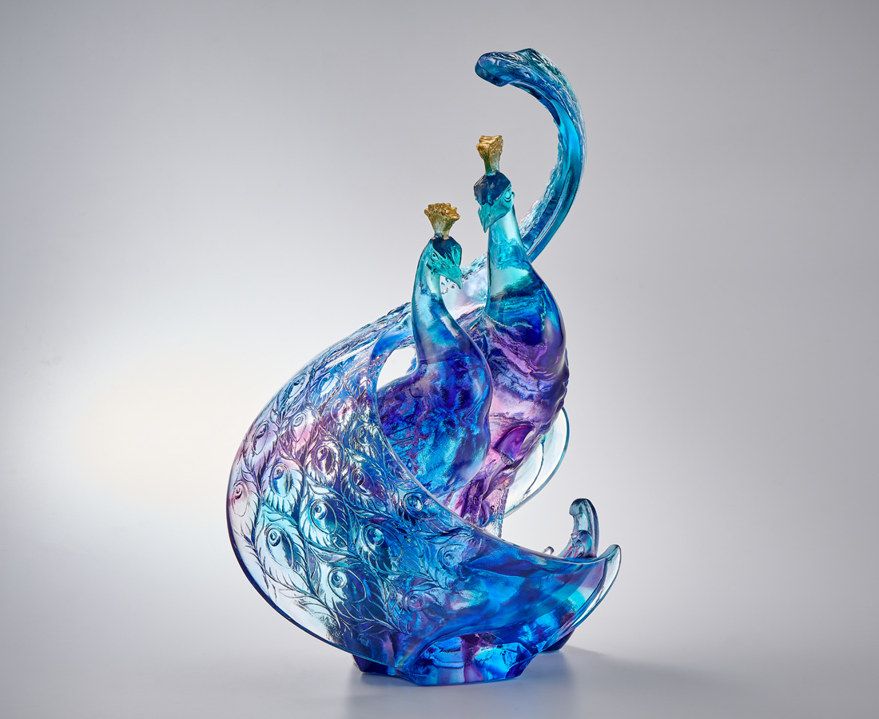
滿滿開屏 兩兩相依
滴滴翠光 融融春色
娓娓細語 奕奕神采
熙熙共景 濃濃情意
天作之合 三生有幸
Peacocks in Companionship
The peacock's gorgeous tail feathers and elegant posture are adored by people, therefore it has many auspicious connotations and is known as the "King of Birds" in Chinese culture. In addition, the image of a peacock spreading its tail conveys the wonderful message of love. Tittot's expertise in lost-wax casting and one-piece molding through thin glass reveals the dynamic beauty of the peacock's spread tail feathers. We hope that this duo of peacocks in companionship represents the ode to everlasting love.

編號 | 1514119 | No | 1514119
名稱 | 三生有幸 | Name | Peacocks in Companionship
顏色 | 藍青紫透+金箔 | Color | Blue, purple, cyan, clear + gilding
尺寸 | 18.6 * 14.9 * 27.2 | Size | 18.6 * 14.9 * 27.2
重量 | 3.7 | Weight | 3.7
限量 | O | Limited Edition | O
售價 | NT$ 36800 | Price | NT$ 36800
 | RMB$ 8180 |  | RMB$ 8180

