金隼穿楊 | 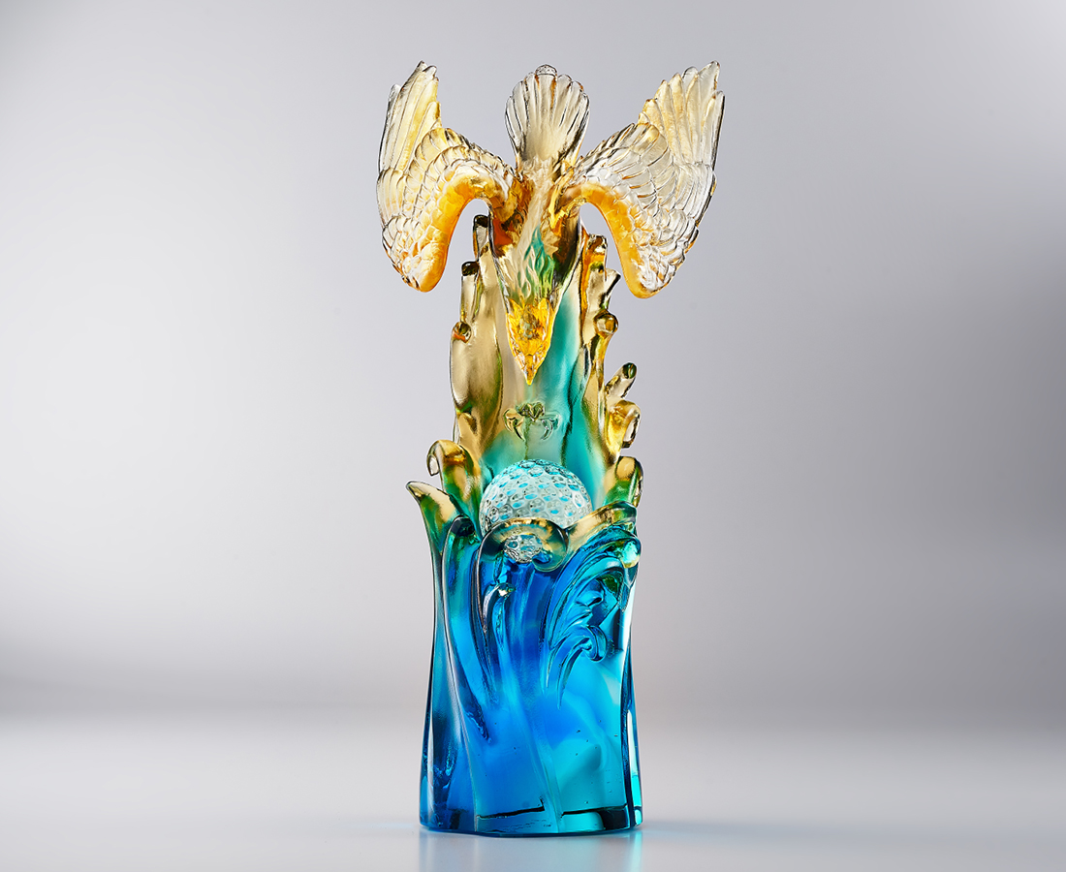
會友綠茵席 九賓爭延譽
好漢身手健 勝負千里決
破風附輕翼 飛馳如金鷹
錦標誇勝捷 眾口喧昇平
The Golden Eagle (Hole-in-One)
Inspired by the culture of golf, the artwork symbolizes the sharpness and determination in pursuing the goal through the gallant posture of the golden eagle swooping down.

編號 | 1514109 | No | 1514109
名稱 | 金隼穿楊 | Name | The Golden Eagle (Hole-in-One)
顏色 | 琥藍青透+透色珠 | Color | amber, blue, cyan, clear + clear ball
尺寸 | 9.5 * 7.5 * 26.5 | Size | 9.5 * 7.5 * 26.5
重量 | 1.3 | Weight | 1.3
限量 | O | Limited Edition | O
售價 | NT$ 13800 | Price | NT$ 13800
 | RMB$ 3080 |  | RMB$ 3080

