錦春 ( 含底座 ) | 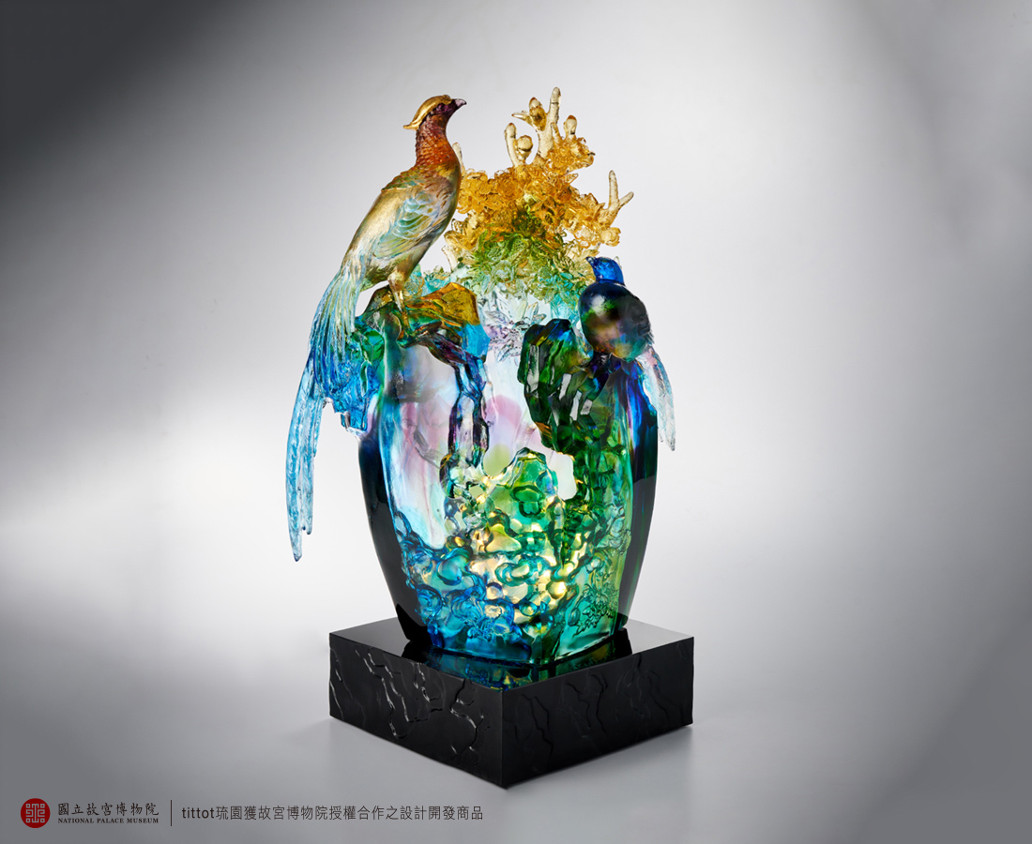
春意芳菲戲來客
錦雞交語寄林園
采采華翼 絲絲豔羨
相伴相知相映
不知曙色薄暮
Exuberant Spring Scenery
In collaboration with the National Palace Museum, the work is inspired by the painting "Beautiful Spring" by Giuseppe Castiglione, a famous Italian painter of the Qing Dynasty. The greatest artistic value of "Beautiful Spring" is the merging of Eastern and Western painting techniques, so our work also borrows from Western cubist thinking by folding different parts of the painting into a three-dimensional structure. In addition, each element of the painting symbolizes auspiciousness and longevity in Chinese culture, and we hope to offer the greatest blessing to the collectors with the beauty of the reinterpreted colored glaze.

編號 | 1514097 | No | 1514097
名稱 | 錦春 ( 含底座 ) | Name | Exuberant Spring Scenery
顏色 | 青綠紫琥透+金箔 | Color | blue, cyan, green, purple, amber, clear
尺寸 | 23.5 * 14 * 30.5 | Size | 23.5 * 14 * 30.5
重量 | 8.0 | Weight | 8.0
限量 | O | Limited Edition | O
售價 | NT$ 62800 | Price | NT$ 62800
 | RMB$ 14000 |  | RMB$ 14000

