翼蔭之歌 | 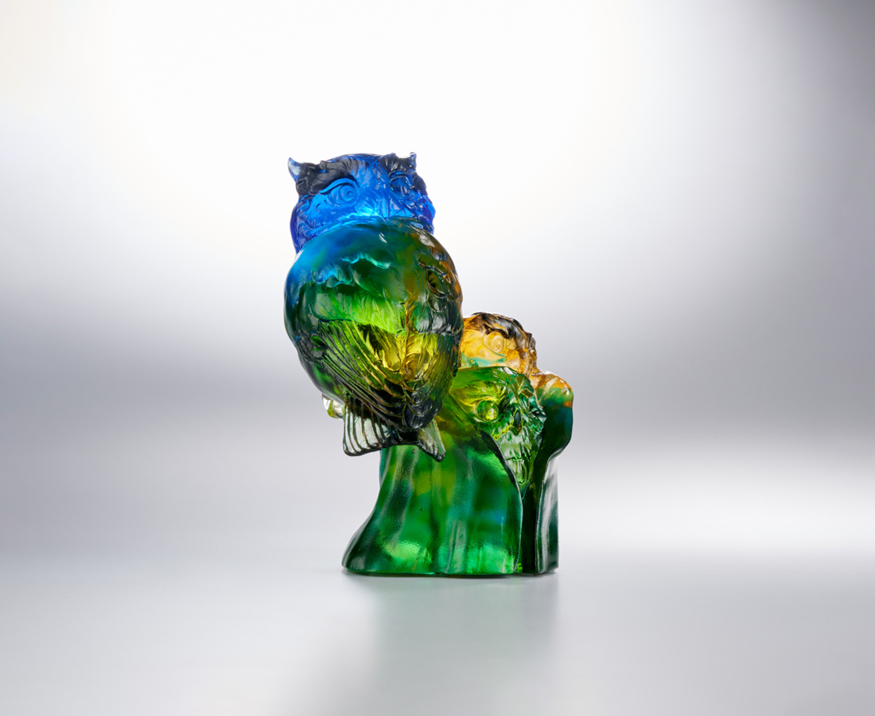
寤
羽翼之下 只管無恙
世界在前方
務
帶著行囊 瀟灑飛翔
家鄉在遠方
悟
惠風和暢 心繫暖陽
夢想在四方
The Owl's Guardianship
The owl, which always moves at night and flies silently, always gives people an imagery of protection and wisdom. Therefore, the work caricatured the owl's habit of hiding its young in a hole in a tree, and the mother's gesture of turning her head to look around, depicting the pure and natural beauty of parent-child interaction among animals.

編號 | 1513997 | No | 1513997
名稱 | 翼蔭之歌 | Name | The Owl's Guardianship
顏色 | 藍綠琥透 | Color | blue, green, amber, clear
尺寸 | 10.7 * 8.5 * 14 | Size | 10.7 * 8.5 * 14
重量 | 1.28 | Weight | 1.28
限量 | X | Limited Edition | X
售價 | NT$ 7980 | Price | NT$ 7980
 | RMB$ 1780 |  | RMB$ 1780

