展鷹姿 | 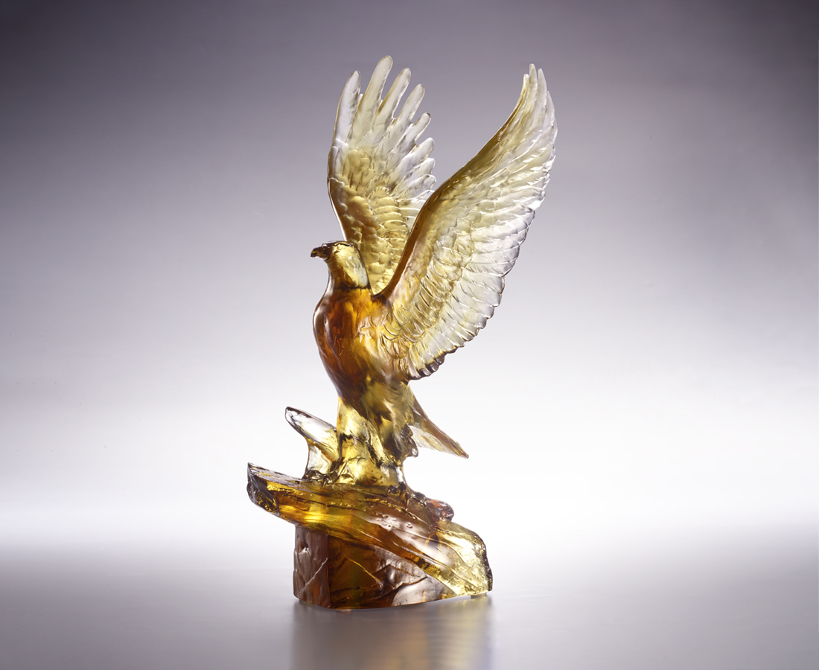
胸懷鴻鵠志
翼展揚鷹姿
王者服眾 自一身傲骨
銳目遠翔 擁蒼穹一方
Wing-spreading Eagle
The majestic eagle spreads its wings with a firm posture, as if it has established its path and direction, ready to fly towards a higher mountain. In Chinese culture, eagles are regarded as divine birds and gods of war. They fly high and see far, serving as a compliment to people's character and spirit.

編號 | 1513994 | No | 1513994
名稱 | 展鷹姿 | Name | Wing-spreading Eagle
顏色 | 茶灰琥透 | Color | brown, gray, amber, clear
尺寸 | 16.2 * 12.5 * 27.5 | Size | 16.2 * 12.5 * 27.5
重量 | 1.35 | Weight | 1.35
限量 | O | Limited Edition | O
售價 | NT$ 13800 | Price | NT$ 13800
 | RMB$ 3290 |  | RMB$ 3290

