錦四喜 | 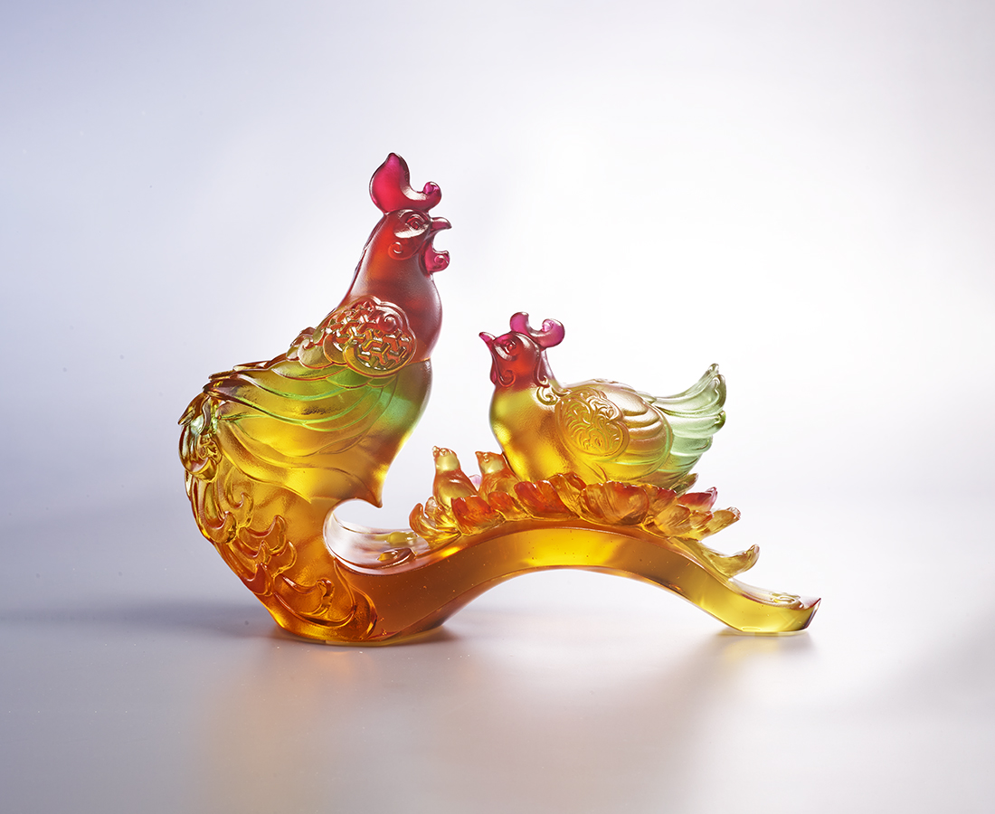
滿宅春花開富貴
閤家錦福報平安
琴瑟合 雛鳳清聲
家⾨順 諸事昌吉
世世相映
代代恬美
Family Fortune
In Chinese culture, the chicken is perceived as a symbol of fortune due to its similar pronunciation with the word. It also symbolizes protection and reassurance, since chickens cluck in the morning, alarming the people of daytime’s arrival. The work therefore presents a family of chickens, conveying the blessings of great chemistry and protection within a family. The red color of the chicken’s head, which required more effort during production, is the special feature of this work.

編號 | 1513984 | No | 1513984
名稱 | 錦四喜 | Name | Family Fortune
顏色 | 紅琥草綠金透 | Color | red, amber, grass green, golden, clear
尺寸 | 21 * 7 * 15 | Size | 21 * 7 * 15
重量 | 1.3 | Weight | 1.3
限量 | O | Limited Edition | O
售價 | NT$ 13800 | Price | NT$ 13800
 | RMB$ 3080 |  | RMB$ 3080

