揚翼高飛 | 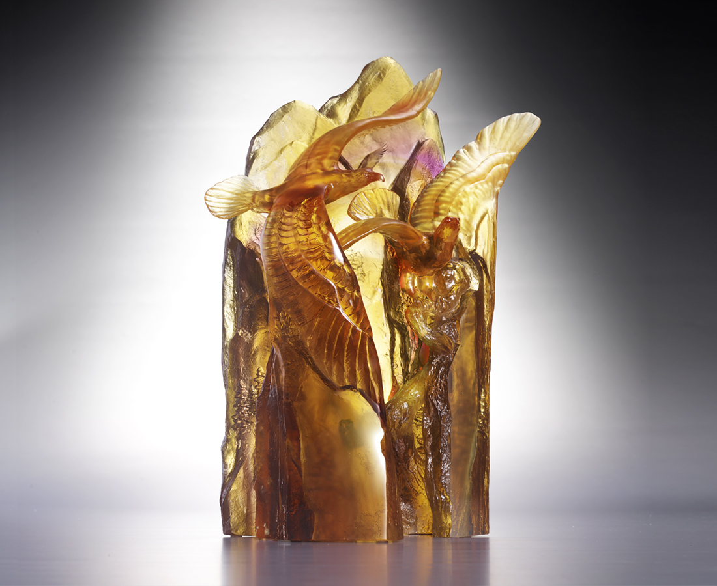
乘著雲霧 乘著風
金黃日光綿延
使命不斷向前
雙翼翻越稜線 競逐最高的山巔
目標是天際 共創榮耀的里程碑
Soaring towards Excellence
The artwork highlights the significance of coexistence and co-prosperity in ecosystems with the imagery of two eagles soaring into the mountains and forests. The imagery also conveys that through both competing and cooperating can two parties exceed limits and reach their highest potential.

編號 | 1513942 | No | 1513942
名稱 | 揚翼高飛 | Name | Soaring towards Excellence
顏色 | 茶琥紫透 | Color | brown, amber, purple, clear
尺寸 | 22 * 13.5 * 32 | Size | 22 * 13.5 * 32
重量 | 6.6 | Weight | 6.6
限量 | O | Limited Edition | O
售價 | NT$ 40800 | Price | NT$ 40800
 | RMB$ 9080 |  | RMB$ 9080

