喜悅雙雙 | 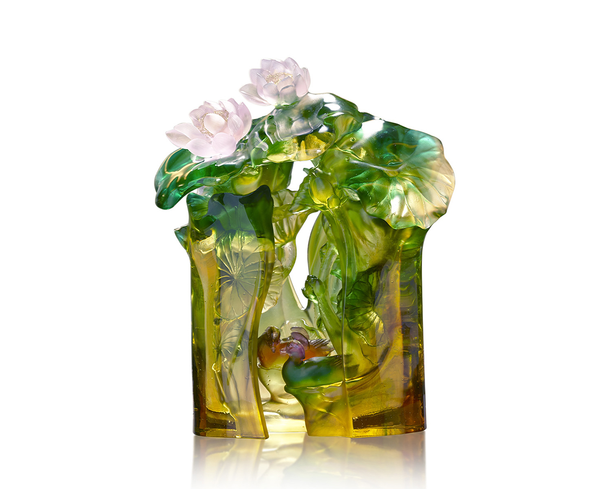
菡萏新花曉並開
鴛鴦相偎池上來
葉無窮碧，花別樣紅
深情不與一般同
相守的喜悅歷歷如繪
幸福在盛夏吐蕊，拍翅雙飛
Double Blessings
The artwork imitates Chinese brush painting by crystal glass, presenting the scenery of lotus pond with mandarin duck. Multilayered, the design creates a peculiar shade of color and infinite depth of field. With the translucent characteristic and different thickness of crystal glass, the artwork illustrates the goodwill between the lotus and mandarin duck.

編號 | 1513898 | No | 1513898
名稱 | 喜悅雙雙 | Name | Double Blessings
顏色 | 金琥茶粉綠青紫透+金箔 | Color | golden, amber, brown, pink greenish, cya
尺寸 | 25 * 15.2 * 31.2 | Size | 25 * 15.2 * 31.2
重量 | 7.7 | Weight | 7.7
限量 | O | Limited Edition | O
售價 | NT$ 62800 | Price | NT$ 62800
 | RMB$ 14000 |  | RMB$ 14000

