珍愛綿長 | 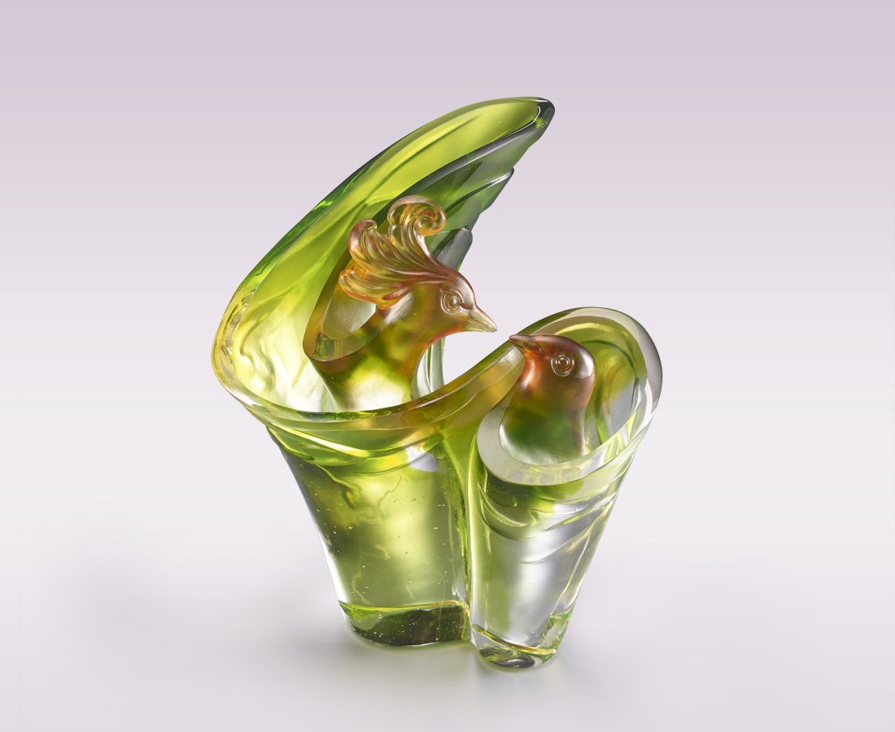
聲聲叮嚀
細細呵護
待 春暖花開 展翅高飛
願 風光明媚 美好綿長
Cherish
The artwork shows a Phoenix enfolding another with its feathers expressing selfish affection, and taking shape as digit 8 conveying endless love and happiness.

編號 | 1513891 | No | 1513891
名稱 | 珍愛綿長 | Name | Cherish
顏色 | 金琥綠透 | Color | golden, amber, green, clear
尺寸 | 16.8 * 15.6 * 18.5 | Size | 16.8 * 15.6 * 18.5
重量 | 2.3 | Weight | 2.3
限量 | O | Limited Edition | O
售價 | NT$ 18800 | Price | NT$ 18800
 | RMB$ 4180 |  | RMB$ 4180

