雲淡松青 | 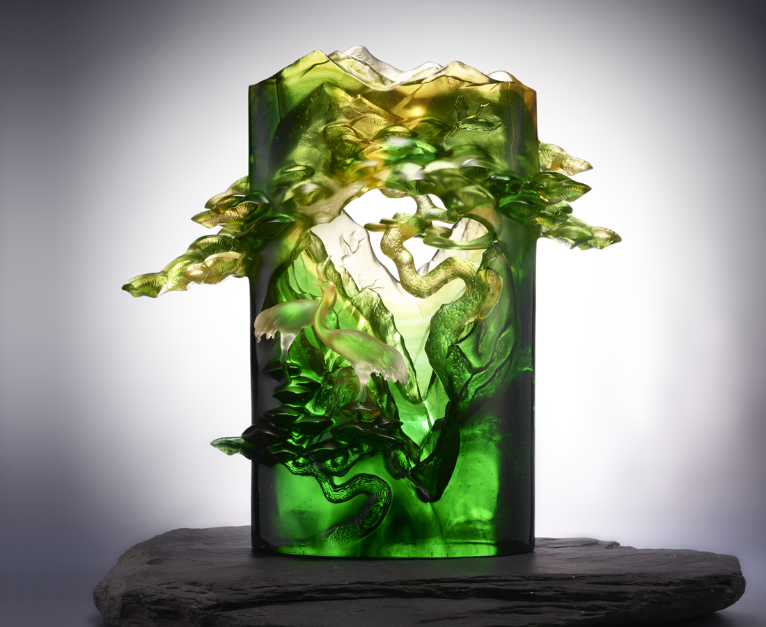
枝葉，在嶙峋孤絕處翱茂
風來聒噪，雨來叨擾
自有微雲淡染成一抹微笑
輕鬆堅持，無須咬牙切齒
根深氣足，厚岩也能破出
層層灑脫放彩，翠綠長在
Potted Landscape with Pines and Cranes
In Chinese culture, the pine and crane symbolizes longevity and a learner’s commitment. Tittot snatches the traditional elements, inserts them into new methods of glass art production, presenting layers of lighting and coloring of the artwork, as if it is a stereoscopic painting. While the artwork sends blessings of happiness, it symbolizes the longevity and commitment Tittot has input into traditional glass art.

編號 | 1513876 | No | 1513876
名稱 | 雲淡松青 | Name | Potted Landscape with Pines and Cranes
顏色 | 藍綠金琥透 | Color | blue, green, golden, amber, clear
尺寸 | 44 * 18 * 44 | Size | 44 * 18 * 44
重量 | 21.0 | Weight | 21.0
限量 | O | Limited Edition | O
售價 | NT$ 238000 | Price | NT$ 238000
 | RMB$ 53000 |  | RMB$ 53000

