傳承 | 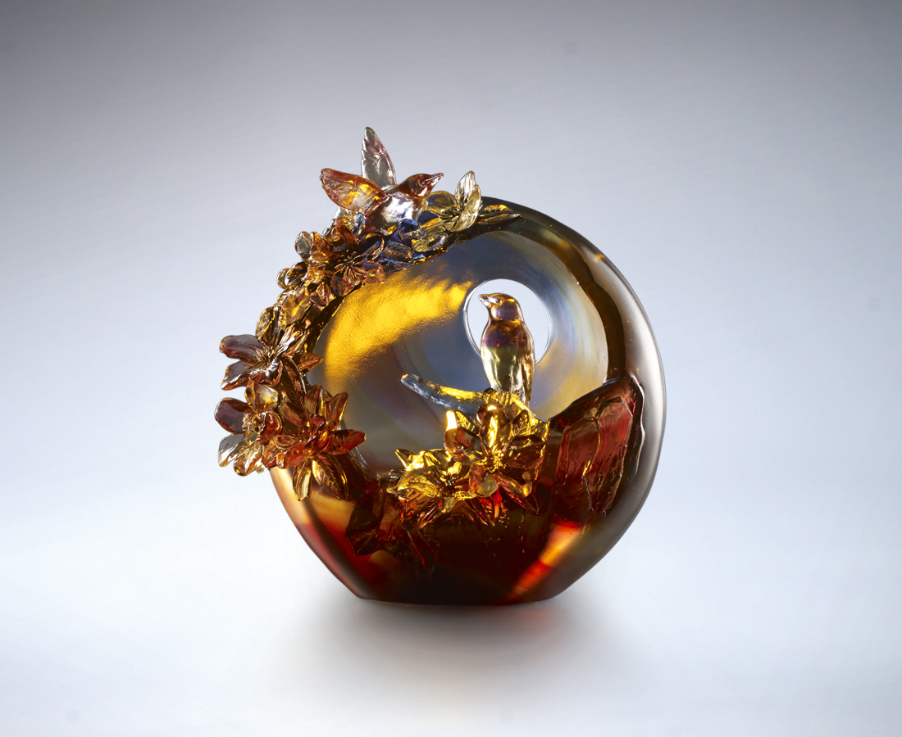
漢宮傳蠟蠋
煙入五侯家
把新的希望
轉交給下一個春日綻放
生命的意義
在於創造繼起的生命
Flower and Bird Lampshade
Using glass to present the views of sunset in spring, the designers of Tittot expressed their praise of life in spring with two birds flying out of the flower bushes making the flowers dance with them.

編號 | 1513788 | No | 1513788
名稱 | 傳承 | Name | Flower and Bird Lampshade
顏色 | 藍紫紅琥透 | Color | blue, purple, red, amber, clear
尺寸 | 17.2 * 11.8 * 18.2 | Size | 17.2 * 11.8 * 18.2
重量 | 2.75 | Weight | 2.75
限量 | O | Limited Edition | O
售價 | NT$ 23800 | Price | NT$ 23800
 | RMB$ 5290 |  | RMB$ 5290

