和諧相契(過故人莊) | 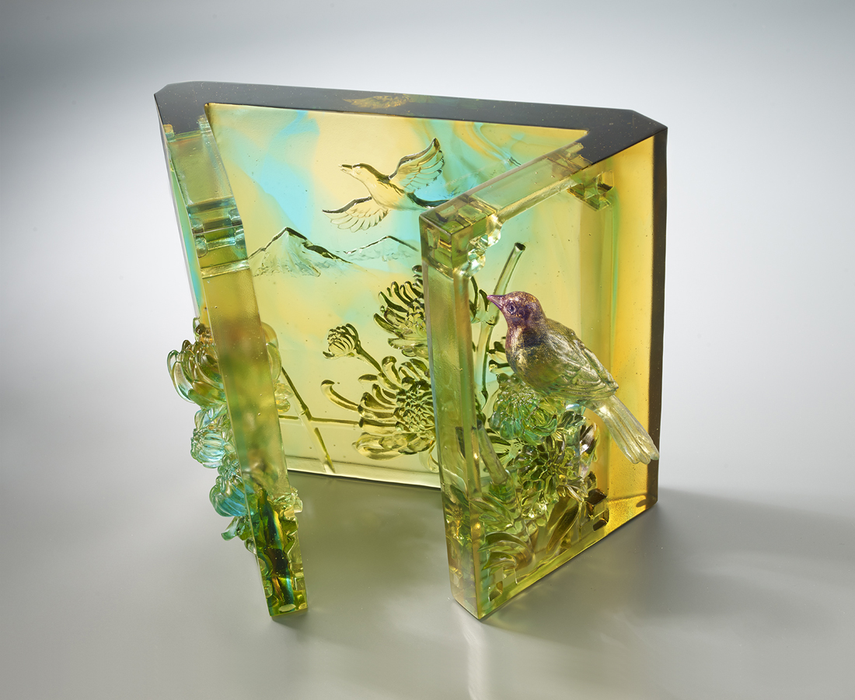
有朋自遠方來
不亦樂乎
寫一個真情問候
開一扇情誼之窗
彼此勉勵 互相關懷
哪怕是相隔萬里
心始終是相印相契
別忘了那多年前的約定
待到重陽日
還來就菊花
Countryside
Tittot uses glass to present the Tang Dynasty poem “Visiting an Old Friend”. Delicate birds, flowers and other rural scenery are symbols of the joy of friends gathered together, and express the sentiment that friendship should be cherished.

編號 | 1513762 | No | 1513762
名稱 | 和諧相契(過故人莊) | Name | Countryside
顏色 | 琥金青紫透＋金箔 | Color | amber, golden, cyan, purple, clear + gil
尺寸 | 19 * 10.6 * 15.5 | Size | 19 * 10.6 * 15.5
重量 | 2.65 | Weight | 2.65
限量 | O | Limited Edition | O
售價 | NT$ 28800 | Price | NT$ 28800
 | RMB$ 6400 |  | RMB$ 6400

