更上一層樓(登鸛雀樓) | 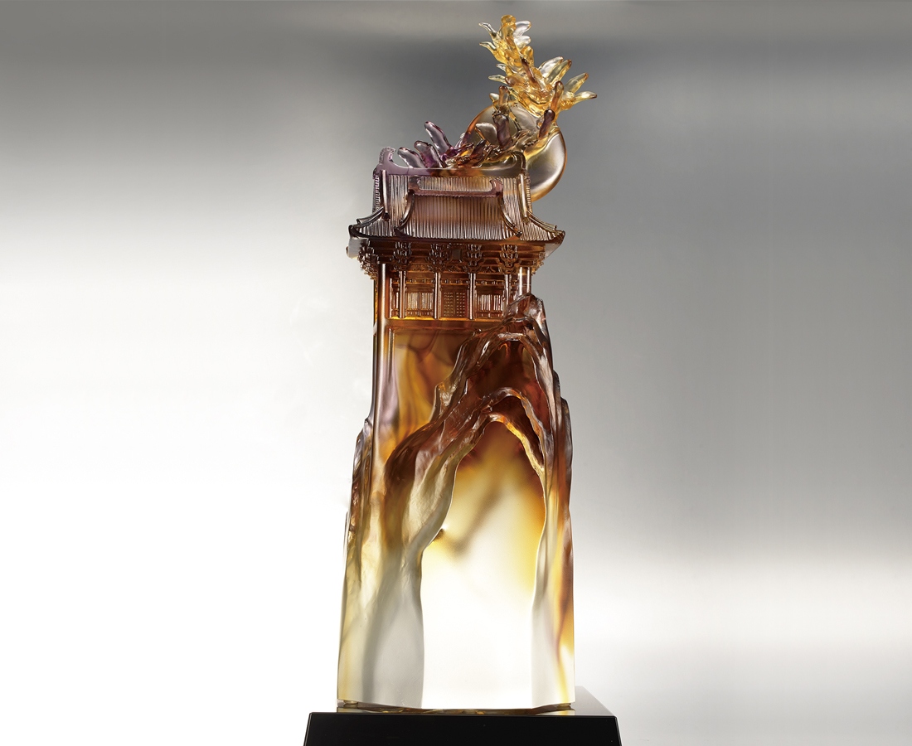
心 不止於此時此刻
那怕願景再艱難
有目標 就奮力向上
欲窮千里目
更上一層樓
歷程縱是險峻
前方也有更動人的風景
The Tower
The tower symbolizes a person’s life achievements, and flying birds denote higher objectives. In this way, the designer exhorts everyone not to be satisfied with the status quo, but to progress to a higher level, and broaden their horizons.

編號 | 1513758 | No | 1513758
名稱 | 更上一層樓(登鸛雀樓) | Name | The Tower
顏色 | 金琥紫透 | Color | golden, amber, purple, clear
尺寸 | 15.4 * 13.1 * 43.5 | Size | 15.4 * 13.1 * 43.5
重量 | 9.6 | Weight | 9.6
限量 | O | Limited Edition | O
售價 | NT$ 48800 | Price | NT$ 48800
 | RMB$ 10900 |  | RMB$ 10900

