雙喜如意 | 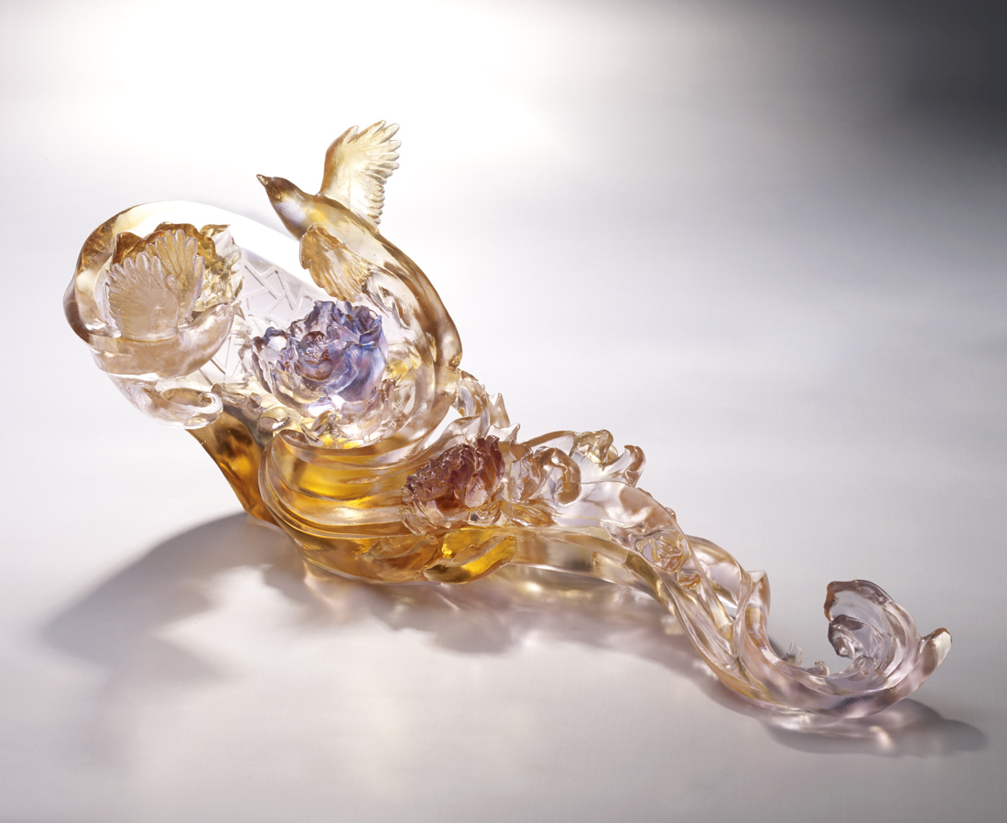
隨風宛轉
傳來春意之聲
時時刻刻
喜事成雙好如意
Magpie Ruyi
Tittot makes the modern Ruyi by redesigned merciful and auspicious elements of magpie, peony, grilles, and curly grass pattern, wishing everybody all kinds of merry in the New Year.

編號 | 1513726 | No | 1513726
名稱 | 雙喜如意 | Name | Magpie Ruyi
顏色 | 紅紫粉透 | Color | red, purple, pink, clear
尺寸 | 42.3 * 17 * 16.7 | Size | 42.3 * 17 * 16.7
重量 | 3.35 | Weight | 3.35
限量 | O | Limited Edition | O
售價 | NT$ 52800 | Price | NT$ 52800
 | RMB$ 11750 |  | RMB$ 11750

