豐年有吉 | 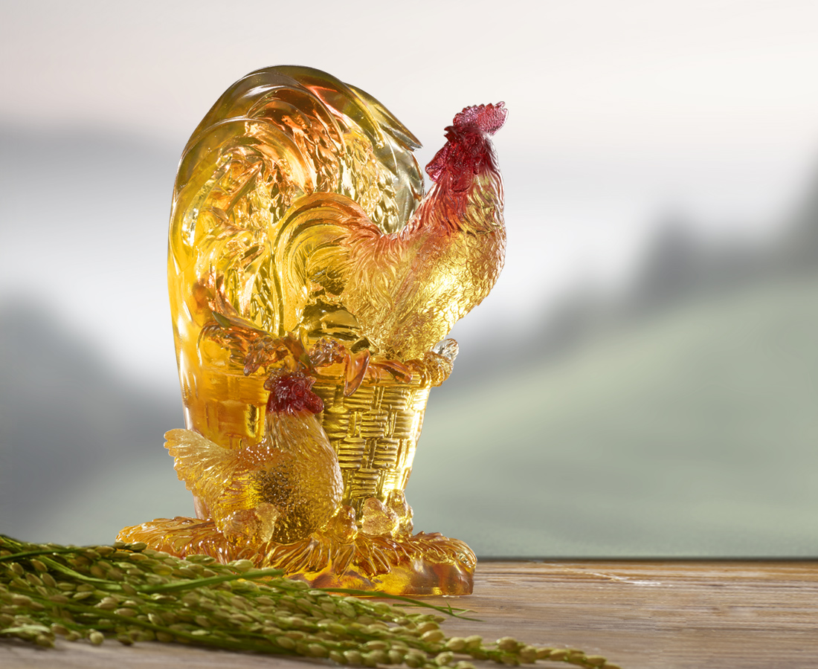
長長久久 豐年常樂
闔家歡欣 代代有福
Chicken and Spike
Tittot uses the chicken and spike in countryside to convey the image of harvest, wishing everyone a prolific fortune in life.

編號 | 1513687 | No | 1513687
名稱 | 豐年有吉 | Name | Chicken and Spike
顏色 | 金紅琥透 | Color | golden ,red ,amber ,clear
尺寸 | 13.8 * 9.4 * 20.3 | Size | 13.8 * 9.4 * 20.3
重量 | 3.3 | Weight | 3.3
限量 | O | Limited Edition | O
售價 | NT$ 18800 | Price | NT$ 18800
 | RMB$ 4180 |  | RMB$ 4180

