知心 | 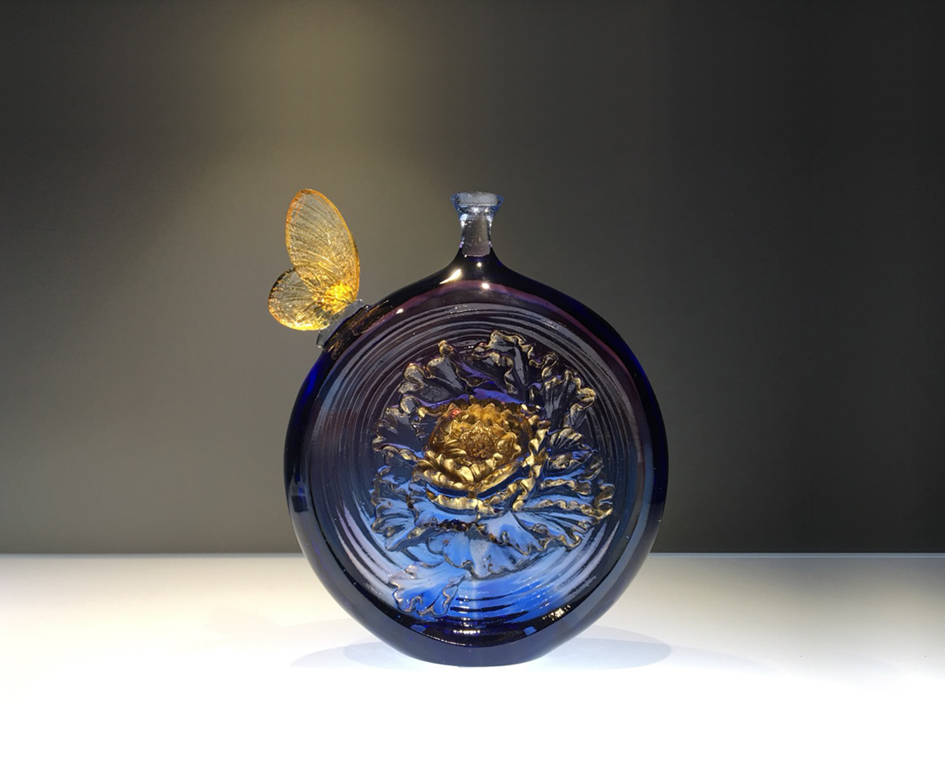
願得一心人
白頭不相離
Peony Vase
The peony blooming inside the glass attracts the Butterfly kissing the vase. To maintain constant passions after stable relationship or long for love between two people suits the art design beautifully.

編號 | 1513651 | No | 1513651
名稱 | 知心 | Name | Peony Vase
顏色 | 藍紫琥透 + 金箔 | Color | blue, purple, amber, clear + gilding
尺寸 | 13.5 * 5 * 15.3 | Size | 13.5 * 5 * 15.3
重量 | 1.05 | Weight | 1.05
限量 | X | Limited Edition | X
售價 | NT$ 7250 | Price | NT$ 7250
 | RMB$ 1600 |  | RMB$ 1600

