包萬象 | 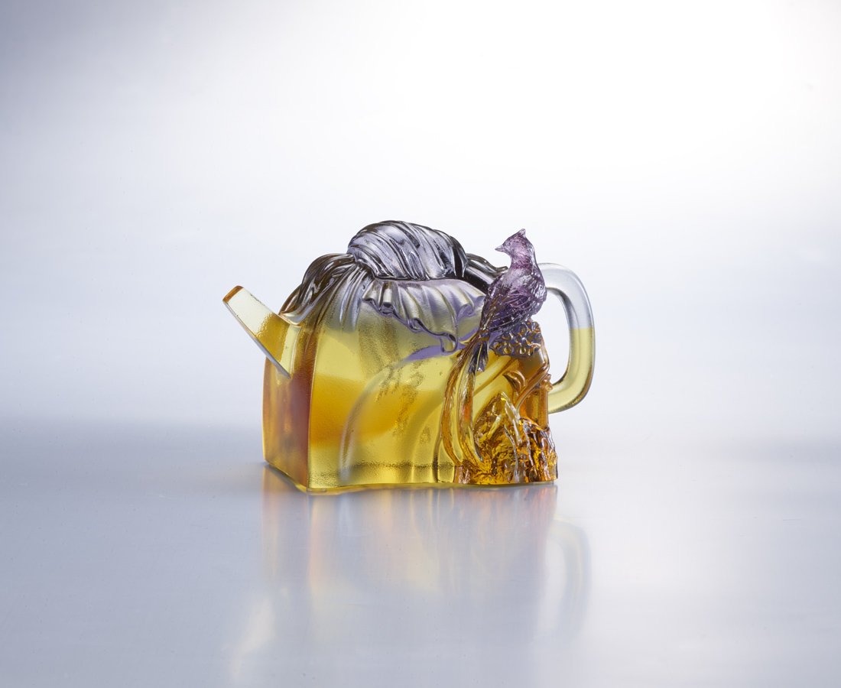
清心也可以
寬容生智慧
包羅萬象
奇趣紛呈
Cloth Wrapper Teapot
In Chinese culture, tea drinking is an art of living with long history. In the Ming Dynasty and Qing Dynasty, craftsmen made teapots into various meaningful and interesting forms so that tea drinking is not only enjoying the taste of tea, but also enjoying the art of visual and tactile. The teapot in a shape of a bundle wrapped in cloth is like a gift. Thereby, it ‘s a symbol of the shared mind of tea-makers.

編號 | 1513578 | No | 1513578
名稱 | 包萬象 | Name | Cloth Wrapper Teapot
顏色 | 紫灰金透 + 扇形底座 | Color | purple , gray , golden , clear ＋ stand
尺寸 | 13.1 * 7.3 * 8.7 | Size | 13.1 * 7.3 * 8.7
重量 | 0.93 | Weight | 0.93
限量 | X | Limited Edition | X
售價 | NT$ 6080 | Price | NT$ 6080
 | RMB$ 1350 |  | RMB$ 1350

