雅韻 | 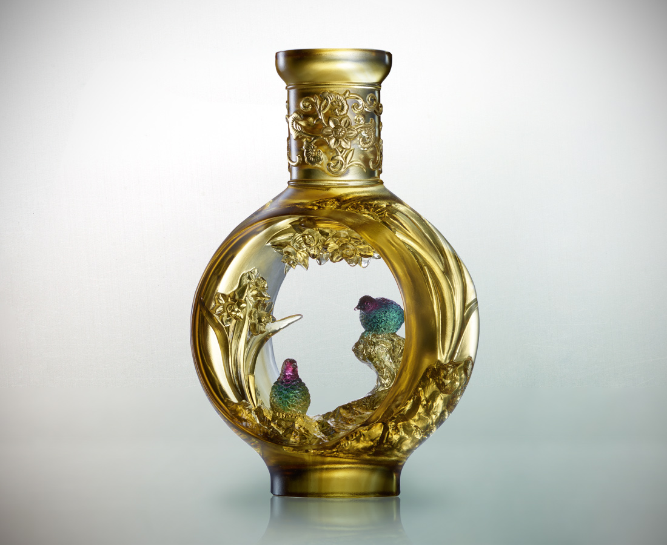
好一個 賞心樂事
月閒意閒
映人間處處是桃源
Narcissus Vase
Inspired by the vases of the Qing Dynasty collected by the National Palace Museum of Taiwan, Tittot designed two magnificent artworks. These two artworks were designed in a way that they can be displayed together as a piece or separately as two individual pieces which allows more versatility and fun; the flower and bird engravings are also among the finest craftsmanship of Tittot.

編號 | 1513573 | No | 1513573
名稱 | 雅韻 | Name | Narcissus Vase
顏色 | 茶金紅綠透 | Color | brown, gold, red, green, clear
尺寸 | 17.7 * 10.5 * 26 | Size | 17.7 * 10.5 * 26
重量 | 2.2 | Weight | 2.2
限量 | O | Limited Edition | O
售價 | NT$ 29800 | Price | NT$ 29800
 | RMB$ 6620 |  | RMB$ 6620

