甜蜜蜜 | 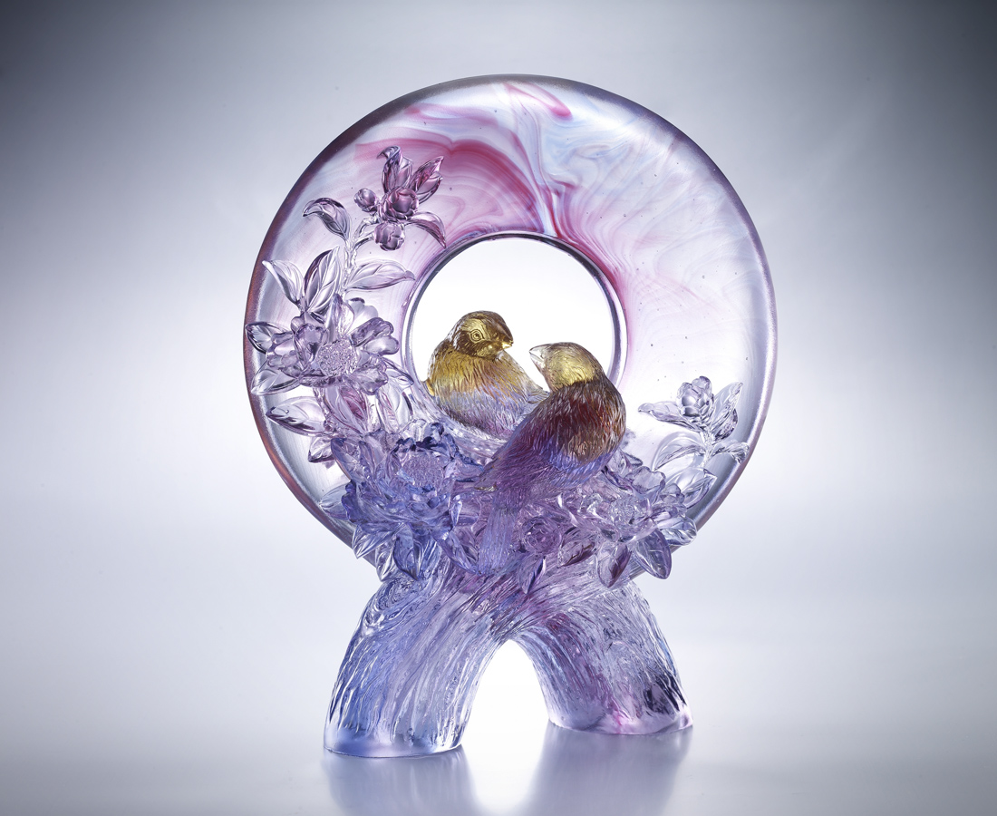
陽光 從樹影灑落成彩虹
喜鵲 將桃實歡唱成香甜
把握每日的點點滴滴
必能釀成滿樹的豐盛
Sweet Love
The artwork shows two birds gazing at each other through the hollow-out center which indicates that we should cherish everyone around us because happiness is just always lurking nearby.

編號 | 1513303 | No | 1513303
名稱 | 甜蜜蜜 | Name | Sweet Love
顏色 | 琥藍紫紅透 | Color | null
尺寸 | 10.6 * 21 * 26 | Size | 10.6 * 21 * 26
重量 | 3.48 | Weight | 3.48
限量 | O | Limited Edition | O
售價 | NT$ 28520 | Price | NT$ 28520
 | RMB$ 28520 |  | RMB$ 28520

