荷喜如意 | 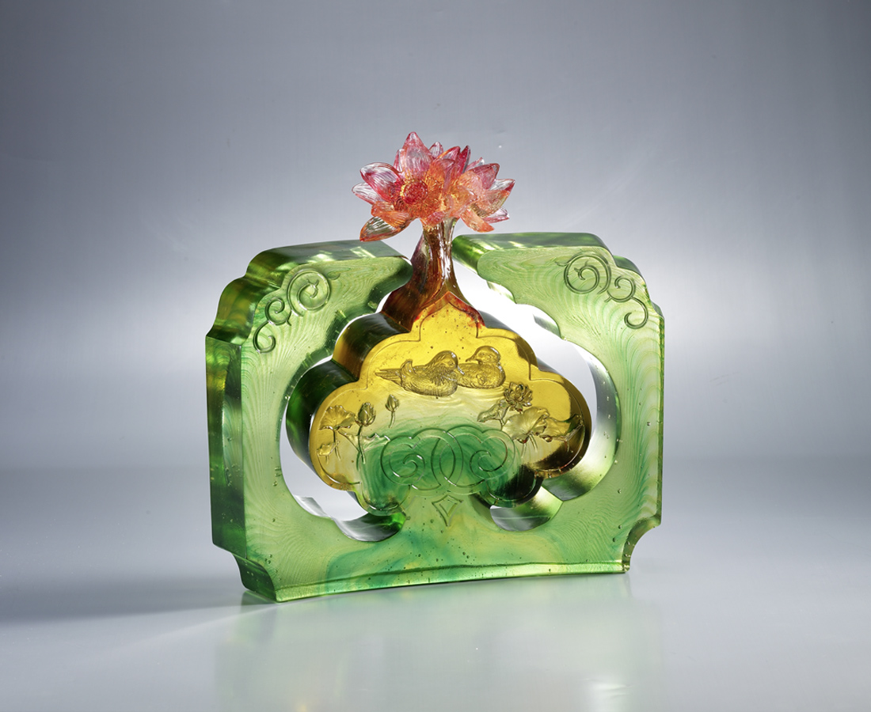
鴛鴦戲荷無限意
春綠水 花更豔
蓮連如意結同心
天上神仙探幾迴
Lotus of Best Wishes
Mandarins playing among the lotuses Mating for life with everlasting love Joyful are the mandarins Greener than the green waters of spring Among the gorgeous lotuses and endless landscapes Touching the hearts of people around And so has good luck befallen Such is the wondrous sight to the envy of the gods

編號 | 1513239 | No | 1513239
名稱 | 荷喜如意 | Name | Lotus of Best Wishes
顏色 | 琥綠紅透 | Color
尺寸 | 8.5 * 26.8 * 26.3 | Size | 8.5 * 26.8 * 26.3
重量 | 7.02 | Weight | 7.02
限量 | O | Limited Edition | O
售價 | NT$ 42800 | Price | NT$ 42800
 | RMB$ 9600 |  | RMB$ 9600

