圓夢風光 | 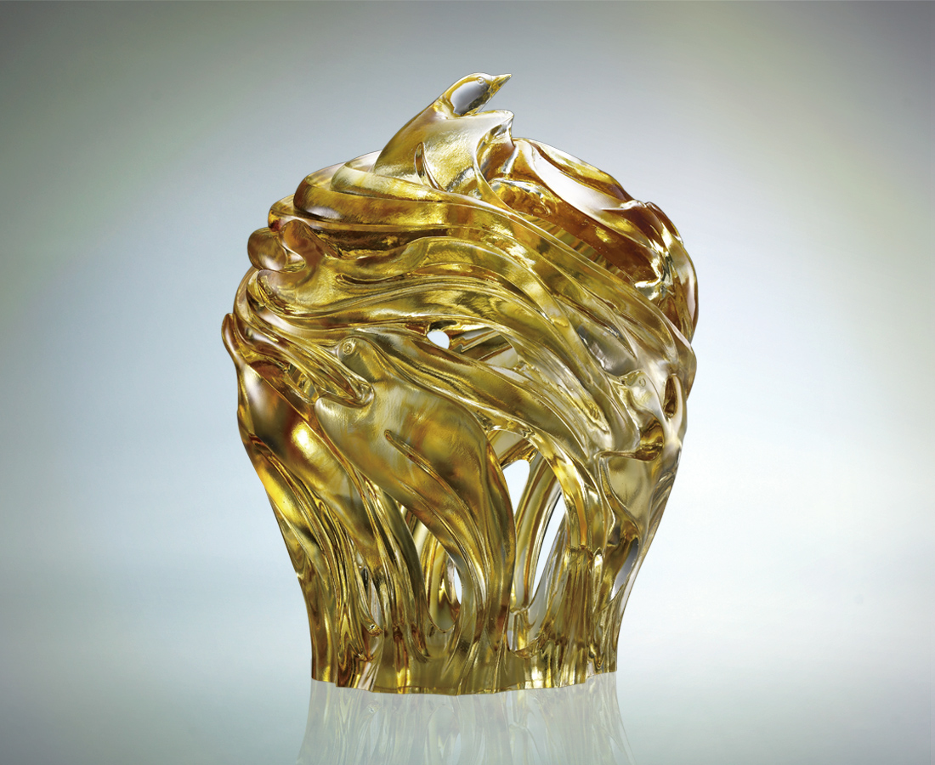
一雙爍亮耀眼
一身優雅自信
燃熱情 鼓風潮
高飛萬萬里青空
願圓年年好風光
Hope with Sky Lantern
Elegance and confidence revealed through a pair of glaring eyes A wave of enthusiasm surged over Soaring high to a borderless blue sky Wishing every year a scene of the great tides

編號 | 1513223 | No | 1513223
名稱 | 圓夢風光 | Name | Hope with Sky Lantern
顏色 | 透 / 金 | Color
尺寸 | 26 * 25.5 * 32.5 | Size | 26 * 25.5 * 32.5
重量 | 11.5 | Weight | 11.5
限量 | O | Limited Edition | O
售價 | NT$ 48800 | Price | NT$ 48800
 | RMB$ 10800 |  | RMB$ 10800

