喜蓮連 | 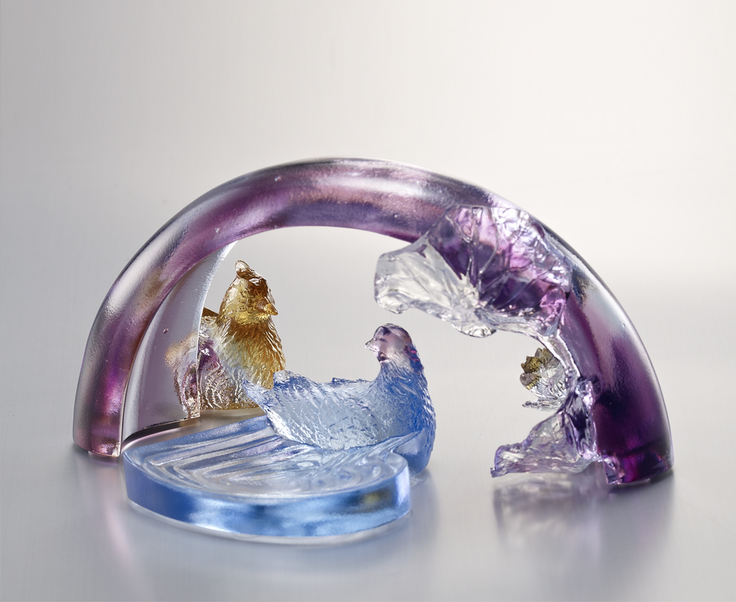
蓮蓮舒放荷氣
橋橋架起繁榮
牽成好事連連
世界多彩多姿
Happiness and Harmony
The atmosphere of harmony Bridges to flourishing prosperity Bring forth succession of good fortunes Enriching the world with vibrant diversity

編號 | 1512905 | No | 1512905
名稱 | 喜蓮連 | Name | Happiness and Harmony
顏色 | 藍紫琥透 | Color
尺寸 | 7.5 * 13.5 * 6.5 | Size | 7.5 * 13.5 * 6.5
重量 | 0.27 | Weight | 0.27
限量 | X | Limited Edition | X
售價 | NT$ 7280 | Price | NT$ 7280
 | RMB$ 1620 |  | RMB$ 1620

