喝彩 | 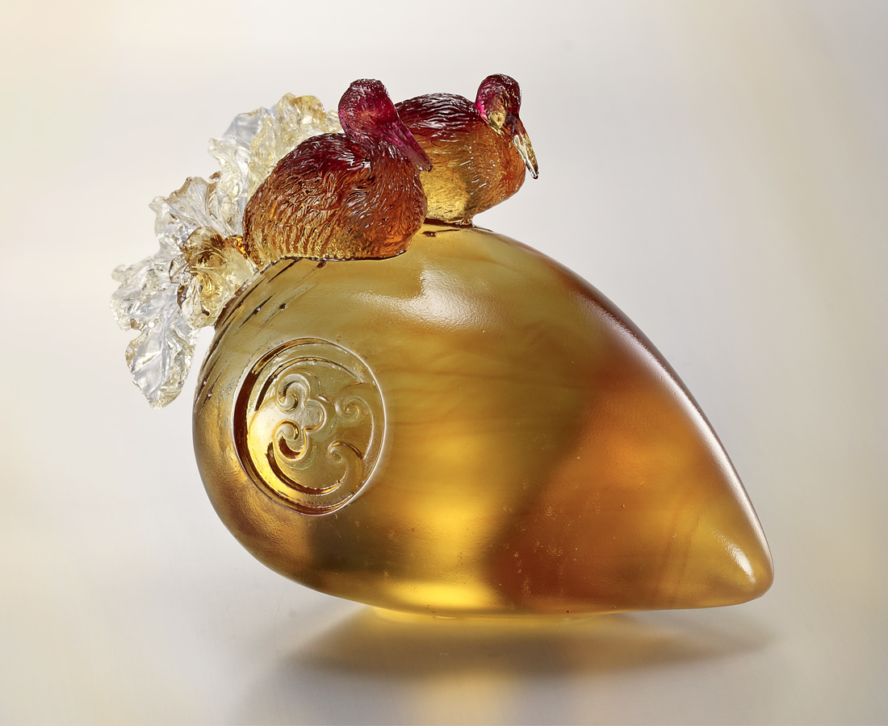
此刻
氣定而神閒
坐享南來北往好時光
壯大鴻運當頭好時機
再為下次喝彩
振翅鼓風
Applause
At this moment Composed and relaxed Enjoying the fruits of previous endeavors Prepared and waiting In anticipation of the opportune moment Flap your wings For another triumphant flight

編號 | 1512896 | No | 1512896
名稱 | 喝彩 | Name | Applause
顏色 | 紅琥透 | Color
尺寸 | 8.2 * 4.5 * 10 | Size | 8.2 * 4.5 * 10
重量 | 1.0 | Weight | 1.0
限量 | X | Limited Edition | X
售價 | NT$ 6280 | Price | NT$ 6280
 | RMB$ 1380 |  | RMB$ 1380

