夢翔成真 | 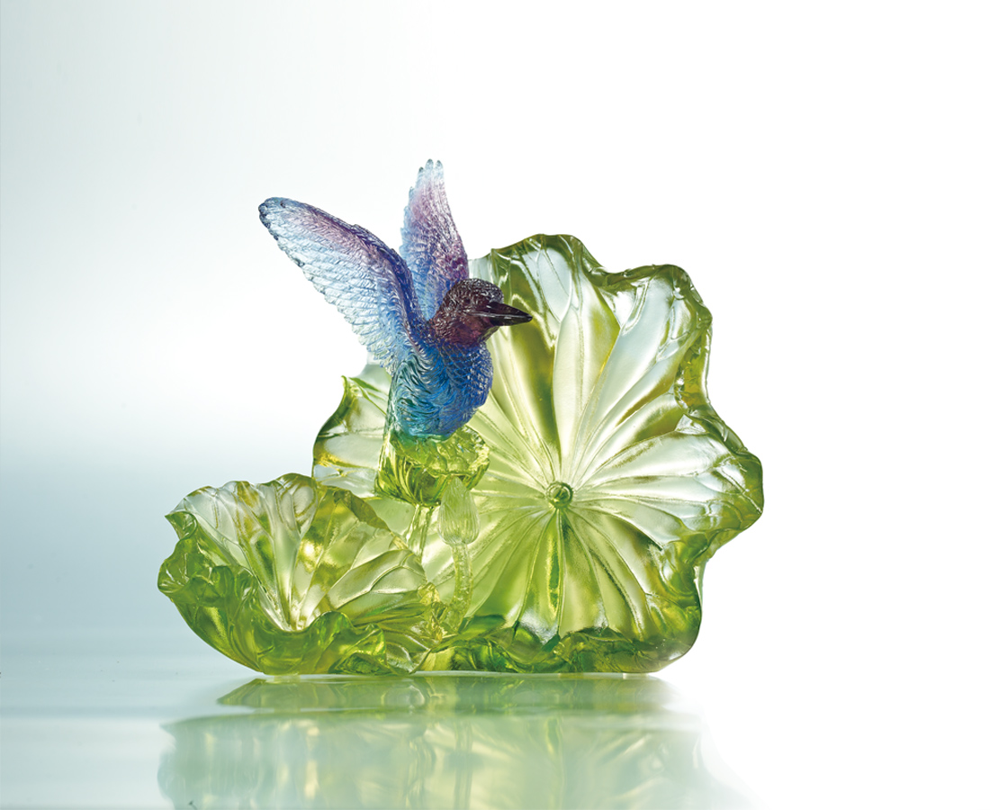
勇於振飛
從天之北越地之南
飛出無比的信心
探向全宇宙
Launching to Success
Launching into the skies With a mighty effort Such confidence and audacity Victory is within sight

編號 | 1512892 | No | 1512892
名稱 | 夢翔成真 | Name | Launching to Success
顏色 | 金綠藍紫透 | Color
尺寸 | 11 * 16.5 * 14 | Size | 11 * 16.5 * 14
重量 | 0.9 | Weight | 0.9
限量 | O | Limited Edition | O
售價 | NT$ 9980 | Price | NT$ 9980
 | RMB$ 2220 |  | RMB$ 2220

