雄風起 | 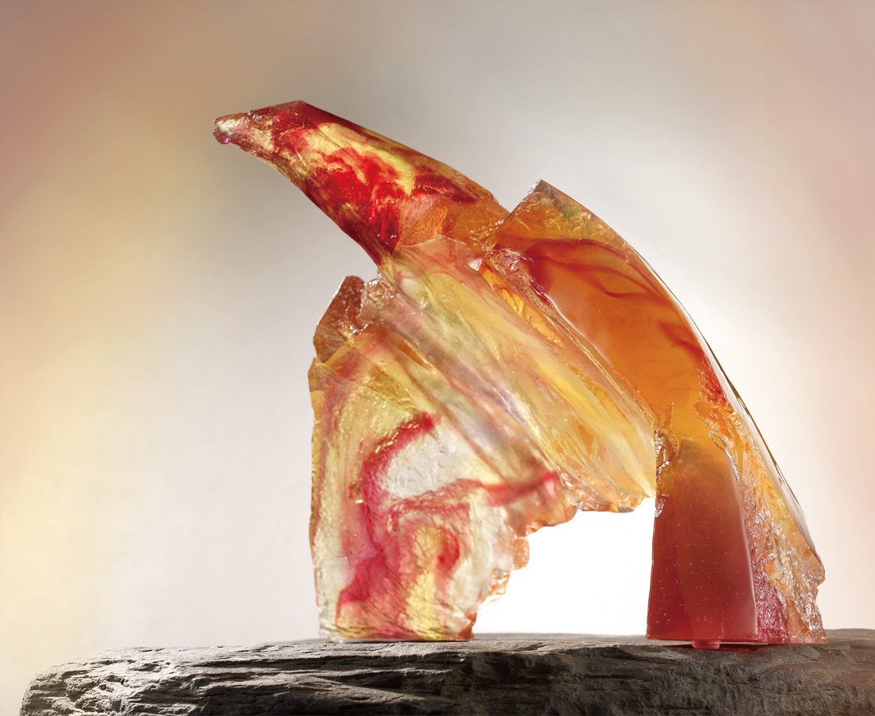
拉高眼界
鼓滿曠達胸襟
鼓足無畏勇氣
振飛雄風萬里之境
Majestic Flight
Perspective heightened Full of aspiration and intrepid audacity Wings extended in majestic flight Sky is the ultimate boundary

編號 | 1512786 | No | 1512786
名稱 | 雄風起 | Name | Majestic Flight
顏色 | 金紅透 | Color
尺寸 | 22.4 * 43.5 * 24.6 | Size | 22.4 * 43.5 * 24.6
重量 | 7.5 | Weight | 7.5
限量 | O | Limited Edition | O
售價 | NT$ 56800 | Price | NT$ 56800
 | RMB$ 13200 |  | RMB$ 13200

