真情天地 | 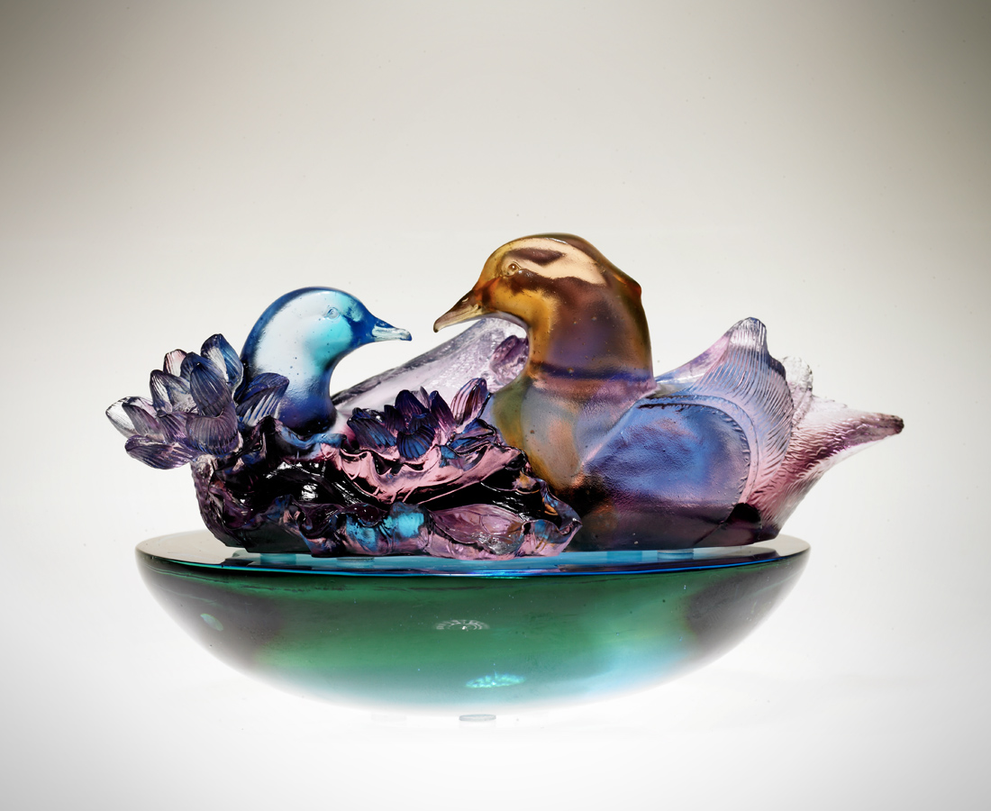
荷諧悠然 柔情似水
真誠一片 天上人間
兩情相印 比肩同心
情義連綿 地設無雙
真情天地
芬芳滿緣 風月無邊
True Love
Gliding in perfect harmony, love gently flowing With sincerity, like heaven on earth Two hearts unite, bound by love A deep and passionate love, second to none A scene of true love A destiny laced with sweet fragrance, picturesque and shaming the surrounding scenery

編號 | 1512451 | No | 1512451
名稱 | 真情天地 | Name | True Love
顏色 | 粉紅紫綠藍透 | Color
尺寸 | 13.5 * 16.7 * 9.5 | Size | 13.5 * 16.7 * 9.5
重量 | 1.6 | Weight | 1.6
限量 | X | Limited Edition | X
售價 | NT$ 9550 | Price | NT$ 9550
 | RMB$ 2388 |  | RMB$ 2388

