梅開情更深 | 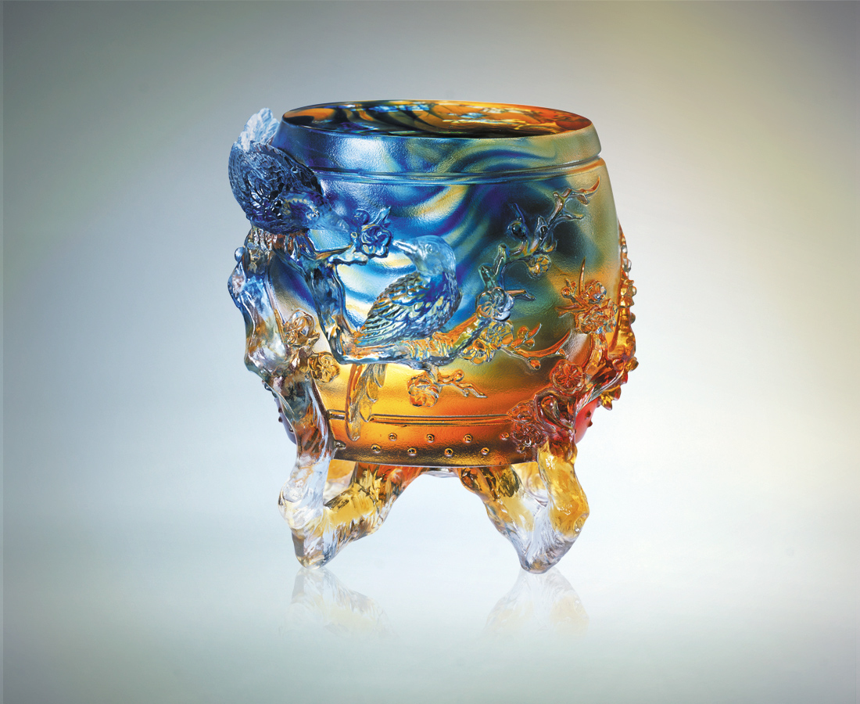
為愛 鑼鼓喧天
慶賀 情意洋溢
為情 深沉敲擊
慶賀 真誠堅貞
為你 一鼓作氣
慶賀 萬象更新
春暖梅開情更深
Feelings Deeper than Plum Blossoms
For love, the sounds of gong and drum soar Celebrate hearts bursting with love For feelings, strike hard and deep Celebrate the sincerity and loyalty For you, I will brace myself Celebrate the new looks of all things Feelings are deeper than the plum blossoms in the warm spring

編號 | 1512106 | No | 1512106
名稱 | 梅開情更深 | Name | Feelings Deeper than Plum Blossoms
顏色 | 藍琥透 | Color
尺寸 | 6.8 * 8.2 * 9.2 | Size | 6.8 * 8.2 * 9.2
重量 | 0.68 | Weight | 0.68
限量 | X | Limited Edition | X
售價 | NT$ 5480 | Price | NT$ 5480
 | RMB$ 1370 |  | RMB$ 1370

