春禧 | 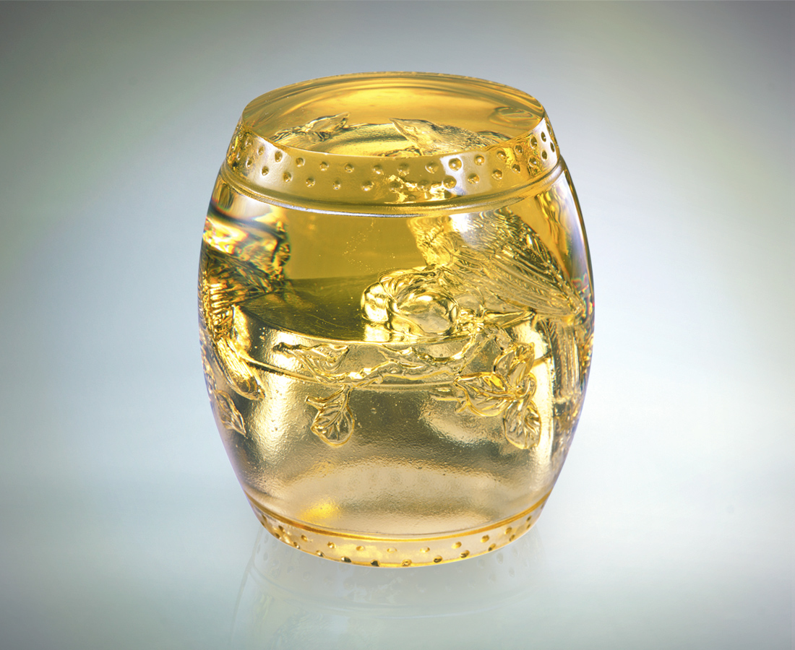
站上好事連連的好運
啁啾心手相連的祝福
鼓吹信心 鼓動勇氣
牢記高瞻遠矚的願景
歌頌有志一同的情誼
為功成名就大張旗鼓
為鼓舞春天情深意濃
Good Tidings of Spring
Relish the benefits of continuous good luck Applaud the harmony of heartfelt blessings Building confidence and courage Remembering the goal of reaching the top Extolling the affection amongst friends with common aspirations Celebrate success with fervor Rejoice in the warmth and camaraderie of Spring

編號 | 1512094 | No | 1512094
名稱 | 春禧 | Name | Good Tidings of Spring
顏色 | 金 | Color
尺寸 | 7 * 7 * 7.5 | Size | 7 * 7 * 7.5
重量 | 0.62 | Weight | 0.62
限量 | X | Limited Edition | X
售價 | NT$ 4980 | Price | NT$ 4980
 | RMB$ 1266 |  | RMB$ 1266

