萬事興旺 | 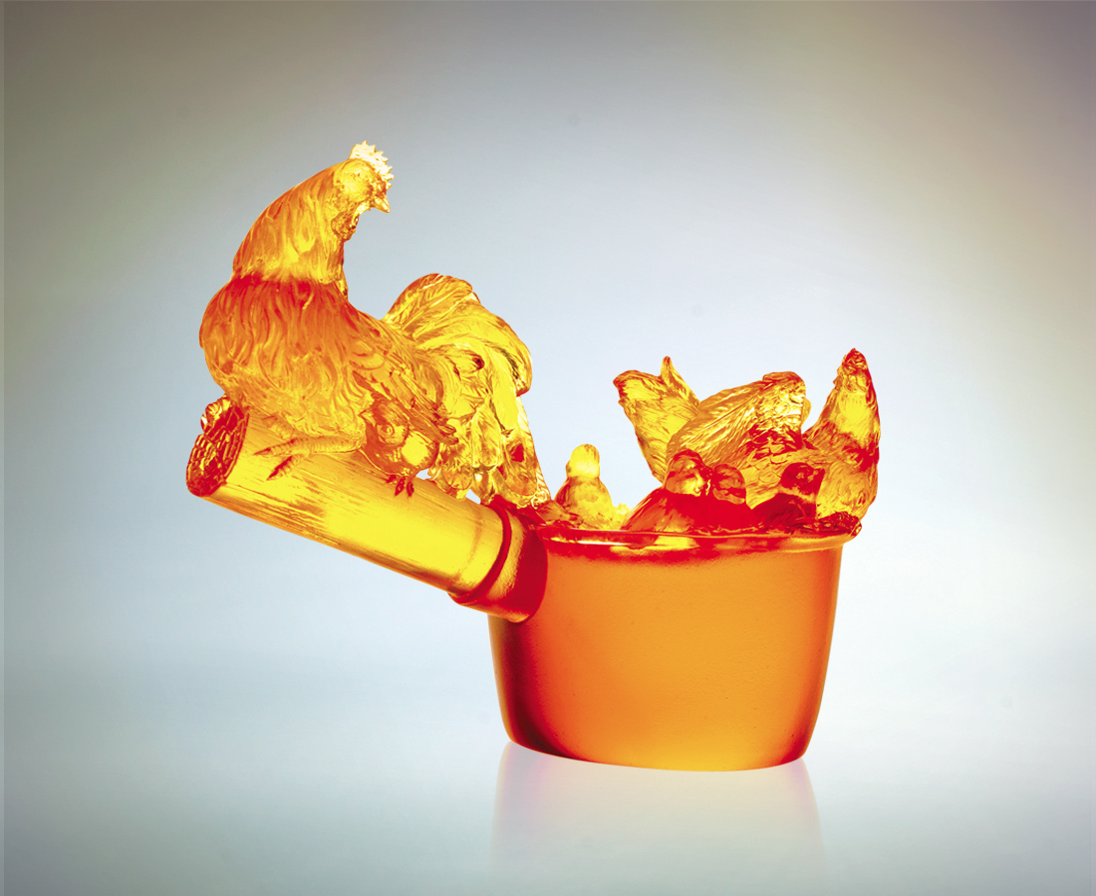
多乘小恆等少乘大
和諧有均衡的美感
剛柔的佈局 關懷的分配
是維持等式的智慧
是合作無間的美德
惜福感恩 和樂融融
裡外關照 事事敏覺
而家大業大萬事興旺
Success in All Endeavors
Regardless of matters big and small Creating an ambience of peace and harmony Exuding both inner strength and tender loving care Maintaining the status quo with exceptional intellect Continuously collaborating – a commendable trait Cherish our blessings and live in harmony Caring for one another with sensitivity and love Generating continued success for home and country

編號 | 1510006 | No | 1510006
名稱 | 萬事興旺 | Name | Success in All Endeavors
顏色 | 琥 | Color
尺寸 | 7.6 * 13.7 * 11 | Size | 7.6 * 13.7 * 11
重量 | 0.79 | Weight | 0.79
限量 | X | Limited Edition | X
售價 | NT$ 6660 | Price | NT$ 6660
 | RMB$ 1666 |  | RMB$ 1666

